# Apache Daffodil™ Extension for Visual Studio Code: Development

## Build Status

## Prerequisites

## Requirements

For *development*, there are some additional prerequisites that are required for building the Apache Daffodil™ Extension for Visual Studio Code:

* [Install SBT 0.13.8 or higher](https://www.scala-sbt.org/1.x/docs/Setup.html)
* [Install Node 10 or higher](https://nodejs.org/en/download/)
* [Install Yarn](https://yarnpkg.com/getting-started/install)
* [Install pandoc](https://pandoc.org/installing.html)

## Suggestions

1. To automatically recompile code when it changes, run:

yarn watch

As watch runs, fix any problems that arise in the Problems tab.

1. Run the Apache Daffodil™ Extension for Visual Studio Code in debug mode.



StartDebugMode

## Build the Apache Daffodil™ Extension for Visual Studio Code and Run It as a Developer

* Clone the project <https://github.com/apache/daffodil-vscode.git>
* Open the project folder in VS Code.
* Run yarn to update the local dependencies.
* Press F5 (or launch “Extension” under the “Run and Debug” pane) to build and launch the extension in another VS Code window.
* In that newly loaded window, named “sampleWorkspace”, you can then debug schema files using the local version of the extension.

The local Apache Daffodil™ Extension for Visual Studio Code downloads and caches the Apache Daffodil™ Debugger corresponding to the latest extension release. If you want to test a *local* version of the Apache Daffodil Debugger, you need to: * add "useExistingServer": true to the configuration in your launch.json in the sample workspace; * launch the backend debugger locally, using a launch configuration like below: json { "type": "scala", "name": "DAPodil", "request": "launch", "mainClass": "org.apache.daffodil.debugger.dap.DAPodil", "args": [] } This will start the debug adapter and await a connection from the Apache Daffodil VS Code Extension (usually on TCP port 4711); and * debug your schema file, as long as it has the useExistingServer setting above.

## Running the Automated Test Suite

The Apache Daffodil VS Code Extension comes with an automated test suite. Run it as follows:

yarn test

### Testing Against a Specific Version of VS Code

By default, the test suite will use the earliest supported release of VS Code. To test against any *specific* version of VS Code (in this example, VS Code version 1.74.3), execute the test suite as follows, setting DAFFODIL_TEST_VSCODE_VERSION to the desired version:

DAFFODIL_TEST_VSCODE_VERSION=1.74.3 yarn test

Set DAFFODIL_TEST_VSCODE_VERSION to stable to use the latest stable release, or to insiders to use the latest (nightly) insiders build.

### TLS Certificate Issues

HTTPS TLS certificates are verified by default. When running the test suite in certain environments (e.g., company VPN that uses endpoint protection), TLS certificate verifications may fail with a self-signed certificate error. If this is the case, either have node trust the endpoint protection certificate, or use one of these workarounds to disable the certificate verification:

NODE_TLS_REJECT_UNAUTHORIZED=0 yarn test

or

node ./out/tests/runTest.js --disable_cert_verification

**WARNING:** Do not export NODE_TLS_REJECT_UNAUTHORIZED=0 into your environment as it will disable TLS certificate verification on *all* node HTTPS connections done in that shell session.

## Building the Documentation

To build docx (Word formatted) documentation, from the top of the cloned repository, run:

cd docs && make all

## Reviewing and Verifying Dependency Bot Updates

For GitHub CI action updates (pull requests that start with **Bump actions/…**), make sure the affected workflows still operate as expected (they are automatically CI tested). GitHub CI actions update workflow YAML files, and are part of the CI infrastructure and not a code dependency. These should be relatively quick and easy to assess compared to code dependencies.

If the updates are not GitHub CI action updates, then additional scrutiny is required. When reviewing and verifying dependency bot updates that are part the software supply chain being distributed, please use the following checklist:

* ☐ **Do all automated continuous integration checks pass?**
* ☐ **Is the update a patch, minor, or major update?**
* ☐ **Is the license still compatible with ASF License Policy?**
* ☐ **Have any changes been made to LICENSE/NOTICE files that need to be incorporated?**
* ☐ **Have any transitive dependencies been added or changed?**

## Monitoring Project Status

Milestone-level project status can be monitored using the [Projects tab](https://github.com/apache/daffodil-vscode/projects) in the [Project’s GitHub repository](https://github.com/apache/daffodil-vscode).

# Apache Daffodil™ Extension for Visual Studio Code: Roadmap

## The Future of the Apache Daffodil™ Extension for Visual Studio Code

While the most recent release of the Apache Daffodil™ Extension for Visual Studio Code focused on the schema and the infoset, the theme of the next version will place additional emphasis on the input data. The input data could be any kind of file, with different byte sizes, byte ordering, and alignments, so having robust hex editing capabilities is important.

It is also important to have the ability to set breakpoints not only in the schema, but also *in the data*, and allow for manipulating the data and watch it affect the parse outcome. In other words, what happens to the parse when the data changes in some way. While stepping through the debugger, the schema, the infoset, and the data views need to be kept in sync.

## Desired Features of the Input Data Editor

For organizational purposes, the desired features for the Apache Daffodil™ Extension for Visual Studio Code are broken down into eight functional areas.

### 1. File Type Support (FTS)

**1.1 The data editor needs to support any fixed length (non-streaming) file Daffodil is capable of opening.** Generally, any file type can be opened and displayed by a hex editor. The file type and extension do not influence the rendering of the file in hex or binary formats.

### 2. User Interface (UI)

**2.1 The data editor needs to be responsive and provide a good VS Code User Experience.** Existing third-party VS Code hex editors will decrease in responsiveness while rendering medium to large size files. The editor will handle file sizes common to Daffodil without impacting overall usability.

**2.2 The data editor needs to be designed as a composition of display panels that allow for multiple data representations to be rendered on the same screen.** A data file may be segmented into multiple representations of data, from differing on byte boundaries to endianness. The editor will render differing representations within the same user interface.

**2.3 The data editor needs to allow individual display panels to maintain their own position in the data to allow viewing different segments of data in different display panels.** The editor will manage each composable view as a separate Viewport capable of displaying a view into the data at a specified offset and capacity.

**2.4 The data editor viewports need to be interactive to allow mouse and keyboard interactions such as scrolling and context menus.** User interaction will drive the function of the editor as such the ability to interpret keyboard and mouse actions on individual and block data selections are critical.

**2.5 The data editor needs to include a Properties View component.** The property view will provide a static region on the display to place file and selection metadata. The property view is not associated to a specific region in the file, so it is not a viewport component. It is tied to events such as selection events and is updated based on notification of events occurring.

**2.6 The data editor needs to include a property display mode for a single unit selection.** The Properties View will allow multiple representations for a single unit, eg byte, to be displayed simultaneously.

**2.7 The data editor needs to include a property display mode for multiple unit selection.** Selecting up to some limit of bytes, for example four, could still be rendered in the Properties View. For example, selecting four bytes could render a 32-bit integer value.

### 3. Persisting Edits (PER)

**3.1 The data editor needs to allow edits to be saved as a new file.** The editor will not attempt to write the file that is held open by Daffodil. Instead, a copy of the file will be written to disk.

**3.2 The data editor needs to provide an auto-incremented file revision number to save without prompting the user.** When saving edits to a file it may be preferrable for the save-as-new-file to be transparent to the user. In this case the user will not be prompted for a file name but instead use an autogenerated name.

**3.3 The data editor needs to provide a save-as option to name a new file.** When saving edits to a file the user may want to specify where the edited file will be saved. In this case a file picker dialog or something similar can be used to allow the user to specify the location for the save file.

**3.4 The data editor will provide a convenient way of restarting the Daffodil debugger with the specified edits.** After saving the edits to a file the debugger can be restarted and automatically set to use the new files path as the input. This convenience allows the user to avoid editing their launch profile to point to the new file.

### 4. Data Representations (DATAREP)

Hex and binary representations for both viewing and editing.

**4.1 The data editor needs to implement support for multiple data representations.** The editor will use the viewport component design to deliver a composable multiple representation rendering capability.

**4.2 The data editor needs to provide a viewport for viewing byte delimited data.** The viewport will display hex bytes similar to the common hex editor displayed.

**4.3 The data editor needs to provide a viewport for viewing data as individual bits.** The viewport will render binary 1-0 display. The details of the rendering such as unit length can be modified using properties associated with the viewport.

**4.4 The data editor needs to provide configurable rendering properties for any given representation.** The UI will allow the user to view and edit viewport properties

**4.5 The data editor needs to provide configurable endianness properties for viewport rendering.** Configuring big or little endian for a viewport.

**4.6 Ability to represent data where MSB or LSB bit can be the first bit displayed.** Ability to view and edit bytes represented in binary where the most significant bit can be the first bit of the byte, or the last bit of the byte.

### 5. Editing (EDT)

**5.1 The data editor needs to implement inline editing within a viewport.** The viewport will support mouse and keyboard interaction to initiate editing a value.

**5.2 The data editor needs to default to editing in the same representation as the view.** The editor will allow editing using the same viewport rendering as the representation, e.g., hex from hex, binary from binary can be represented using the native rendering logic of the viewport.

**5.3 The data editor needs to provide undo / redo capability related to edits.** A common expectation of editors such as this would be to provide commands to undo and redo edits that have been made.

**5.4 The data editor needs to provide editing in differing representations as the view.** The editor could provide something similar to a pop-out component that allows editing a value in a format that differs from the viewport representation, e.g., editing binary from the hex view.

### 6. Debugger integration (DBG)

**6.1 The debugger needs to provide extension points which allow executing debug commands from the editor.** There are certain non-standard operations such as setting breakpoints on data locations that are to be supported. This will require the debugger to provide extension points that allow the editor to pass instructions that augment the debugger flow.

**6.2 The debugger will support breakpoints to be set at data positions in the input file.** Setting breakpoints on data locations indicates to the debugger that when the input stream reaches a specified point in the file it will break execution as if it hit a code breakpoint.

**6.3 The data editor will allow breakpoints to be set at data positions in the input file.** The data editor will allow creation of and then render data breakpoints in a similar way to how code breakpoints are set and rendered.

**6.4 The data editor will support starting debug from a specified position.** The editor provides a function via a context menu that indicates a starting point in the file for the input stream. This will drop all bytes prior to this location when starting the debug.

**6.5 The data editor will support stopping debug at a specified position.** The editor provides a function via a context menu that indicates the stopping point in the input stream. All data after this point will be ignored by the input stream, ending the debug at the specified point.

**6.6 The debugger will support the latest version of Apache Daffodil™ released.** The extension will be kept up to date with the latest version of Apache Daffodil™.

### 7. Editing Commands (CMD)

In this section a “block” is defined as a range that has been selected by the user.

**7.1 The data editor needs to support adding individual bytes.** The editor will provide a function to insert a single byte at a position in the file.

**7.2 The data editor needs to support adding blocks of bytes.** The editor will provide a function to insert multiple bytes starting at a position in the file.

**7.3 The data editor needs to support deleting individual bytes.** The editor will provide a function to delete a single byte from the file.

**7.4 The data editor needs to support deleting blocks of bytes.** The editor will provide a function to delete blocks of bytes from the file.

**7.5 The data editor needs to support modifying the value of an individual byte.** The editor will provide a function to overwrite the value of a byte in the file.

**7.6 The data editor needs to support modifying the value of a block of bytes.** The editor will provide a function to overwrite the value of a block of bytes in the file.

**7.7 The data editor needs to support copying byte(s).** The editor will provide the ability to select and copy a range of bytes to the clipboard for convenience and interoperability. The size of bytes that can be copied will need an upper limit depending on the file size and system memory availability.

**7.8 The data editor needs to support pasting byte(s).** The editor will provide the ability to past bytes from the system clipboard into the file at a specified position for convenience and interoperability.

**7.9 The data editor needs to support searching for patterns**. The editor will provide a search function similar to a text editor find text using literal text. This pattern would literally be searched for in each given representation.

**7.10 The data editor needs to support replacing search results with new patterns.** The editor will provide a search function similar to a text editor find text using literal text and replace the found text with alternate text. This pattern would literally be searched for in each given representation and replaced using text that is valid within said representation.

**7.11 The data editor needs to use the native clipboard provided by the operating system for interoperability with other applications.** The editor will use the operating system clipboard for copy and paste operations to improve interoperability with other applications.

**7.12 The data editor needs to support applying a bit mask to an individual byte.** The editor will provide function to apply a mask to a byte at a position in the file.

**7.13 The data editor needs to support applying a bit mask to a block of bytes.** The editor will provide a function to apply a mask to a selection of bytes in the file.

### 8. Test Data Markup Language integration (TDML)

**8.1 All external files needed by the TDML file will be incorporated as relative paths into the TDML file.**

**8.2 TDML features need to be as modular as possible.** Modularization allows for the future removal of TDML from the repository of the DFDL extension and addition to a library that can be shared by the DFDL repository.

**8.3 TDML features need to be written in Scala and will read/write XML by using XML bindings (e.g., Jaxb/scalaxb).**

**8.4 The extension needs to provide an item in the command palette (ctrl + shift + p) for ‘Generate TDML File’.**

Selecting this command will display menus allowing the user to select the following:

* TDML File Name
* Name for the test case
* Description for the test case
* DFDL Schema
* Data Document

This selection will work in the same way as the DFDL debugger. If the user selects the command from a DFDL Schema, it will automatically use that in place of a selection.

* The TDML File will be created in the workspace directory.
* The DFDL Schema and Document files will be file names only.
* These file names will be relative to the workspace directory. It will be the responsibility of the user to organize everything when creating a TDML file and to package the files up for distribution.
* The name of the TDML file will be the name of the DFDL schema used with ‘.tdml’ appended to the end.

**8.5 The extension needs to provide an item in the command palette (ctrl + shift + p) for ‘Add Test Case to TDML File’.**

Selecting this command will display menus allowing the user to select the following:

* TDML File Name
* Name for the test case
* Description for the test case
* DFDL Schema
* Data Document

This selection will work in the same way as the DFDL debugger. If the user selects the command from a DFDL Schema, it will automatically use that in place of a selection.

**8.6 The extension needs to provide an item in the command palette (ctrl + shift + p) for ‘Run Test Case in TDML File’.**

Selecting this command will display menus allowing the user to select the following:

* TDML File Name
* Test Case to run (this list will be populated with data in the selected TDML File)

This command will start the Daffodil process in run mode. This command will provide an option to start the Daffodil process in debug mode. The location of the DFDL Schema is expected to be relative to the location of the TDML File. It will be the responsibility of the user who created the TDML file to ensure that packaging of their TDML file is correct.

### IntelliSense Auto Completion (INT)

**9.1 The extension needs to provide context sensitive auto completion suggestion (IntelliSense) based on the DFDL language.**

**9.2 The IntelliSense suggestions for attributes needs to supply an appropriate list of choices where applicable.**

**9.3 The IntelliSense for element tags needs to supply attribute appropriate for that specific tag.**

**9.4 The IntelliSense for element tags needs to supply attribute suggestions for newly insert tags as well as editing existing tags.**

**9.5 The IntelliSense needs to supply suggestions based on the contextual cursor position.**

**9.6 The IntelliSense suggestions need to work when multiple tags are on a single line as well as when each tag is on a single line.**

**9.7 IntelliSense needs to supply a closing tag when a closing tag is missing.**

**9.8 IntelliSense suggestions need to work when attributes are split on multiple lines.**

### DFDL Schema Syntax Colorization (SYN)

**10.1 Provide DFDL syntax colorization.**

**10.2 Matching tags within the dfdl schema need to be highlighted.**

**10.3 XPath expressions embedded within dfdl schema should be highlighted.**

## Release Plan (Proposed)

The goal is to have these Apache Daffodil VS Code Extension capabilities incrementally released, and published to the Marketplace every few months.

The following table will be updated as new releases are published, or the themes/emphasis of a release change.

However, this is all highly subject to change based on the needs of the user community, and on what community developers choose to work.

The semantic versioning release identifications are also subject to change.

| Release | Published to Marketplace? | Description | Issues |
| --- | --- | --- | --- |
| 1.1.0 Target: July, 2022 | ✅ Yes | UI wireframes showing a vision of the data editor has been posted for discussion and feedback. The main editing viewport now has support for the delete and insert editing primitives in addition to overwrite. Support for multiple viewports, being able to undo and redo changes, cut and paste, and file saving are implemented. | [Issues](https://github.com/apache/daffodil-vscode/issues?q=+is%3Aissue+milestone%3A1.1.0+) |
| 1.2.0 Target: December, 2022 | ✅ Yes | Search and replace is implemented. Full-stack testing is in place. | [Issues](https://github.com/apache/daffodil-vscode/issues?q=+is%3Aissue+milestone%3A1.2.0+) |
| 1.3.0 Target: July, 2023 | ✅ Yes | Improvements to DFDL auto-completion (aka, “Intellisense”). Basic support for TDML. Editing is permitted in any of several viewports. Each viewport can display data in different formats (e.g, binary, hex, ascii, big and little endian integers). | [Issues](https://github.com/apache/daffodil-vscode/issues?q=+is%3Aissue+milestone%3A1.3.0+) |
| 1.3.1 Target: August, 2023 | ✅ Yes | Refinement of DFDL auto-completion (aka, “Intellisense”), Data editor large file support, mode simplification, incremental search and replace, updates to views and selections, multitasking support, data profiler, content discovery and editing additions | [Issues](https://github.com/apache/daffodil-vscode/issues?q=+is%3Aissue+milestone%3A1.3.1) |
| 1.4.0 Target: November, 2023 | ❌ Not yet | Unicode detection and profiling, language guessing, adjustable viewports, additional data display features, segment saving to file, streaming transforms MVP, breakpoints can be set at data offsets and debugging can start and stop at specified offsets. | [Issues](https://github.com/apache/daffodil-vscode/issues?q=+is%3Aissue+milestone%3A1.4.0) |

## Beyond 1.4.0:

Support for:

* A Properties View component.
* Automated checkpoints.
* Transformations of a byte range (with checkpoints allowing undo/redo).
* Additional encodings in the data editor.

More to come…

# Apache Daffodil™ Extension for Visual Studio Code

The Apache Daffodil™ Extension for Visual Studio Code is an extension to the Microsoft® Visual Studio Code (VS Code) editor which enables Data Format Description Language (DFDL) syntax highlighting, code completion, and the interactive debugging of DFDL Schema parsing operations using [Apache Daffodil™](https://daffodil.apache.org/).

DFDL is a data modeling language used to describe file formats. The DFDL language is a subset of eXtensible Markup Language (XML) Schema Definition (XSD). Just as file formats are rich and complex, so is the modeling language to describe them. Developing DFDL Schemas can be challenging, requiring a lot of iterative development, and testing.

The purpose of Apache Daffodil™ Extension for Visual Studio Code is to ease the burden on DFDL Schema developers, enabling them to develop high quality, DFDL Schemas, in less time. VS Code is free, open source, cross-platform, well-maintained, extensible, and ubiquitous in the developer community. These attributes align well with the Apache Daffodil™ project and the Apache Daffodil™ Extension for Visual Studio Code.

## Bundled Tools in the Apache Daffodil™ Extension for Visual Studio Code

### DFDL Syntax Highlighting

DFDL is rich and complex. Developers using modern code editors expect some degree of built-in language support for the language in which they are developing, and DFDL should be no different. The Apache Daffodil™ Extension for Visual Studio Code provides syntax highlighting to improve the readability and context of the text. In addition, the syntax highlighting provides feedback to the developer indicating the structure and code appear syntactically correct.

### DFDL Schema Code Completion

The Apache Daffodil™ Extension for Visual Studio Code provides code completion, also known as “Intellisense”, offering context-aware code segment predictions that can dramatically speed up DFDL Schema development by reducing keyboard input, memorization by the developer, and typos.

### Daffodil Data Parse Debugger

The Apache Daffodil™ Extension for Visual Studio Code provides a Daffodil Data Parse Debugger which enables the developer to carefully control the execution of Apache Daffodil™ parse operations. Given a DFDL Schema and a target data file, the developer can step through the execution of a parse line by line, or until the parse reaches some developer-defined location, known as a break point, in the DFDL Schema. What is particularly helpful is that the developer can watch the parsed output, known as the “infoset”, as it’s being created by the parser, and see where the parser is parsing in the data file. This enables the developer to quickly discover and correct issues, improving DFDL Schema development and testing cycles.

### Data Editor

The Apache Daffodil™ Extension for Visual Studio Code provides an integrated data editor as a new *experimental* feature that is currently under development. It is akin to a hex editor, but tuned specifically for challenging Daffodil use cases. It is designed to support virtually any sized file, well beyond the limits of the standard text editor in VS Code, and it can handle non-text data just as well as text data. It has support for setting Daffodil debugger breakpoints on offset positions *in the data file* in addition to the positions in the DFDL Schema. It handles non-standard byte sizes, non-aligned bytes, and byte ordering where the Least Significant Byte (LSB) can be the first or last bit in a byte. As an editor designed for Daffodil developers by Daffodil developers, features of the tool will evolve quickly to address the specific needs of the Daffodil community.

# Prerequisites

This guide assumes VS Code and a Java Runtime Environment (Java 8 or greater) are installed.

* [Install VS Code](https://code.visualstudio.com/download)
* [Install Java Runtime 8 or greater](https://docs.oracle.com/goldengate/1212/gg-winux/GDRAD/java.htm#BGBFJHAB)
* On Linux, glibc 2.31 or greater is required

# Installing the Apache Daffodil™ Extension for Visual Studio Code

The Apache Daffodil™ Extension for Visual Studio Code can be installed using one of two methods.

## Option 1: Install the Apache Daffodil™ Extension for Visual Studio Code From the Visual Studio Code Extension Marketplace

The Apache Daffodil™ Extension for Visual Studio Code is available in the [Visual Studio Code Extension Marketplace](https://marketplace.visualstudio.com/vscode).

## Option 2: Install the Latest .Vsix File From the Apache Daffodil™ Extension for Visual Studio Code Release Page

The latest .vsix (the file extension used for VS Code extensions) file can also be downloaded from the Apache Daffodil™ Extension for Visual Studio Code [releases page](https://github.com/apache/daffodil-vscode/releases) and installed by either:

* Using the command-line via code --install-extension <path-to-downloaded-vsix-file>; or
* Using the “Extensions: Install from VSIX” command from within VS Code by opening the Command Palette (Mac = Command+Shift+P, Windows/Linux = Ctrl+Shift+P), and typing vsix to bring up the command and pointing it at the downloaded .vsix file, as demonstrated in the following animation.



# DFDL Schema Authoring Using Code Completion

## Set the Editor to “dfdl” mode

Since DFDL Schema files end with .xsd (XML Schema Definition or XSD), the editor needs to be informed specifically that DFDL mode is desired over the more general XML mode, the following animation demonstrates how to set the desired mode for DFDL.



## DFDL Schema Authoring Features

Auto suggest is triggered using control space or typing the beginning characters of an item, as demonstrated in the following animation.



📝 **NOTE:** Intellisense is *context aware*, so there is no need to begin a block with <, just start typing the tag name and code completion will automatically handle it as appropriate.

Typing one or more unique characters will further limit the results, as demonstrated in the following animation.



Code completion can be used to add the schema block, with just a couple of keystrokes, as demonstrated in the following animation.



Code completion can make short work out of completing a DFDL Format Block, offering context-sensitive suggestions for the format attribute values, as demonstrated in the following animation.



The > or / characters are used to close XML tags. Use tab to select an item from the drop down and to exit double quotes, as demonstrated in the following animation.



Code completion supports creating self-defined dfdl:complextypes and dfdl:simpleTypes, as demonstrated in the following animation.



The tab key can be used to complete an auto-complete item within an XML tag. After auto-complete is triggered, typing the initial character or characters will limit the suggestion results. Inside an XML tag a space or carriage return will trigger a list of context sensitive attribute suggestions, as demonstrated in the following animation.



The following animation demonstrates how code completion can be used to efficiently help create self-defined types.



The following animation demonstrates how code completion can be use to efficiently create xs:choices and dfdl:discriminators.



The following animation demonstrates how code completion can help authors use hidden references and dfdl:inputValueCalc.



The following animation demonstrates how code completion can help with creating elements using dfdl:outputValueCalc.



The following animation demonstrates examples of code completion assisting in the creation of more user-defined types.



XPath expressions can be code completed. The following animation demonstrates how the Path expressions are completed when calculating dfdl:Length values.



The following animation demonstrates how code completion can be used to help create dfdl:assert blocks.



The following animation demonstrates another couple of examples of dfdl:assert block creation using code completion.



## Known Issues With Code Completion

1. The Apache Daffodil™ Extension for Visual Studio Code uses a clunky method to auto complete curly braces within quotes. It is anticipated that this will be better addressed in the future. The auto complete method blocks suggestions while typing between the beginning quote, opening curly brace and the closing curly brace, ending quote.

# Debugging a DFDL Schema Using the Apache Daffodil™ Extension for Visual Studio Code’s Bundled Daffodil Data Parse Debugger

## Debug Configuration

Debugging a DFDL Schema needs both the DFDL Schema to use and a data file to parse. Instead of having to select the DFDL Schema and the data file each time from a file picker, a “launch configuration” can be created, which is a JSON description of the debugging session.



To create the launch profile:

1. Select Run -> Open Configurations from the VS Code menubar. This will load a launch.json file into the editor. There may be existing configurations, or it may be empty.
2. Press Add Configuration... and select the Daffodil Debug - Launch option.

Once the launch.json file has been created it will look something like this

{  
 "type": "dfdl",  
 "request": "launch",  
 "name": "Ask for file name",  
 "program": "${command:AskForProgramName}",  
 "stopOnEntry": true,  
 "data": "${command:AskForDataName}",  
 "infosetOutput": {  
 "type": "file",  
 "path": "${workspaceFolder}/infoset.xml"  
 },  
 "debugServer": 4711  
}

This default configuration will prompt the user to select the DFDL Schema and data files. If desired, the “program” and “data” elements can be mapped specifically to the user’s files to avoid being prompted each time.

📝 Note: Use ${workspaceFolder} for files in the VS Code workspace and use absolute paths for files outside of the workspace.

{  
 "type": "dfdl",  
 "request": "launch",  
 "name": "DFDL parse: My Data",  
 "program": "${workspaceFolder}/schema.dfdl.xsd",  
 "stopOnEntry": true,  
 "data": "/path/to/my/data",  
 "infosetOutput": {  
 "type": "file",  
 "path": "${workspaceFolder}/infoset.xml"  
 },  
 "debugServer": 4711  
}

## Launch a DFDL Parse Debugging Session

Using the launch profile above a DFDL parse: My Data menu item at the top of the Run and Debug pane (Command-Shift-D) will display. Then press the play button to start the debugging session.



In the Terminal, log output from the DFDL debugger backend service will display. If something is not working as expected, check the output in this Terminal window for hints.

The DFDL Schema file will also be loaded in VS Code and there should be a visible marking at the beginning where the debugger has paused upon entry to the debugging session. Control the debugger using the available VS Code debugger controls such as setting breakpoints, removing breakpoints, continue, step over, step into, and step out.

## Other Options for Launching a DFDL Parse Debugging Session

* **Option 1:**
  + Open the DFDL Schema file to debug
  + From inside the file open the Command Palette (Mac = Command+Shift+P, Windows/Linux = Ctrl+Shift+P)
  + Once the command Palette is opened start typing Daffodil Debug:
    - Option 1 = Daffodil Debug: Debug File - This will allow for the user to fully step through the DFDL Schema. Once fully completed, it will produce an infoset to a file named SCHEMA-infoset.xml which it then opens as well.
    - Option 2 = Daffodil Debug: Run File - This will run the DFDL Schema, producing the infoset to a file named SCHEMA-infoset.xml.
* **Option 2:**
  + Open the schema file to debug
  + Click the play button in the top right, two options will be provided:
    - Option 1 = Debug File - This will allow for the user to fully step through the schema (WIP). Once fully completed, it will produce a infoset to a file named SCHEMA-infoset.xml which it then opens as well.
    - Option 2 = Run File - This will run the DFDL Schema, producing the infoset to a file named SCHEMA-infoset.xml which it then opens as well.

## Custom DFDL Debugger Views

### Infoset Tools

Find the infoset tools from the command menu (Mac = Command+Shift+P, Windows/Linux = Ctrl+Shift+P)



### Inputstream Hex Viewer

Find the hex view from the command menu (Mac = Command+Shift+P, Windows/Linux = Ctrl+Shift+P)



hex-view

# Enable Experimental Features in the Apache Daffodil™ Extension for Visual Studio Code

To enable the Apache Daffodil™ Extension for Visual Studio Code experimental features, from the command menu start typing ‘daffodil’, then select Daffodil Debug: Enable Experimental Features, then select Yes.



## Data Editor

🧪 **Warning:** This is currently an experimental feature in development.

Ωedit is being integrated as the experimental data editor in the Apache Daffodil™ Extension for Visual Studio Code. Once experimental features are enabled, find the Data Editor in the command menu by typing ‘omega’, then select OmegaEdit: Data Editor.

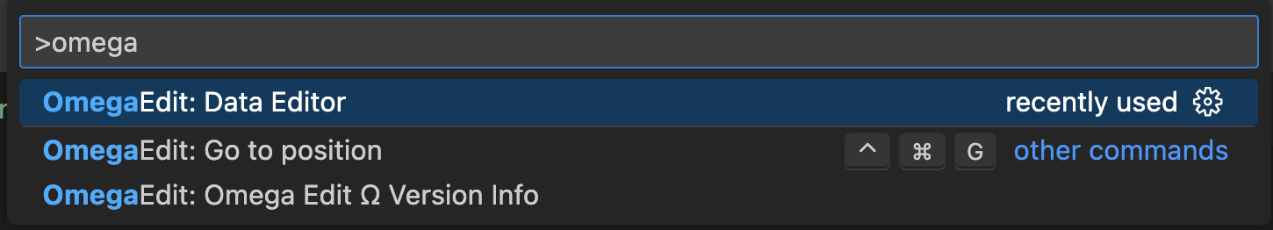

After selecting a file to edit, a Data Editor tab will appear.

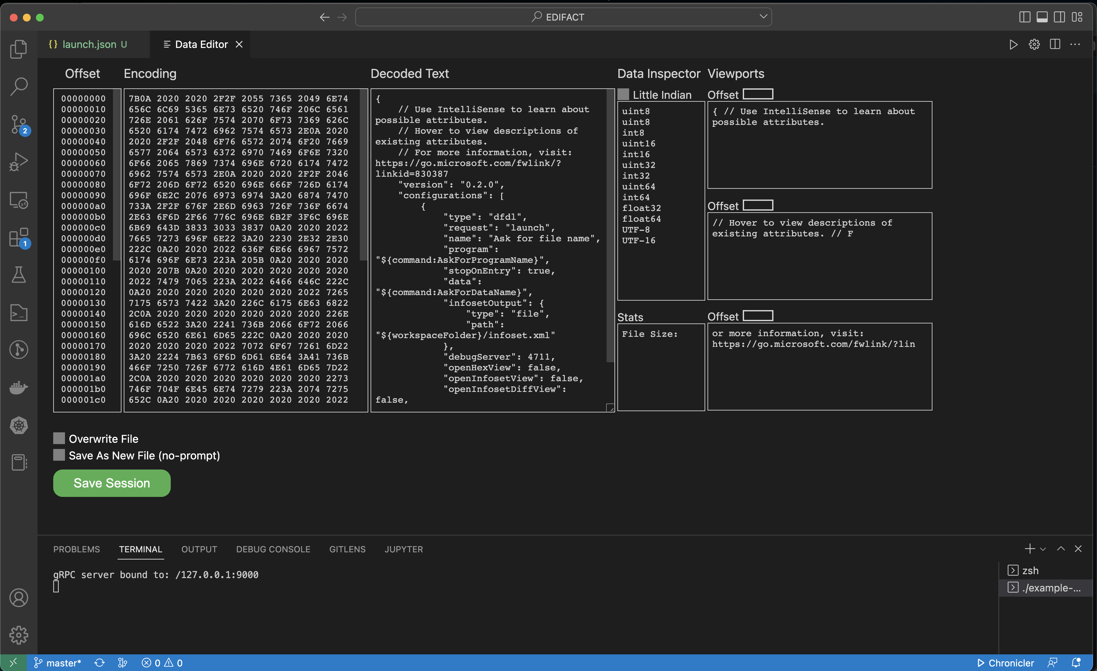

As of v1.2.0, this experimental feature is far from functional, but will be improving over time.

# Common Errors and Solutions

1. Wrong Java Development Kit (JDK). Be sure Java 11+ is running.

On MacOS, using Homebrew:

# Install Java 11 from a macOS terminal  
brew install java11

Add change JAVA_HOME in the ~/.zshrc file (or equivalent):

# Java 11  
export JAVA_HOME=/usr/local/Cellar/openjdk@11/11.0.12

Be sure code is in the PATH by following the instructions [here](https://code.visualstudio.com/docs/setup/mac).

With JAVA_HOME set to the Java 11 install, run code in the terminal.

# Reporting Problems and Requesting New Features

If problems are encountered or new features are desired, create tickets [here](https://github.com/apache/daffodil-vscode/issues).

# Getting Help

If additional help or guidance on using Daffodil and its tooling is needed, please engage with the community on [mailing lists](https://daffodil.apache.org/community/) and/or review the [archives](https://lists.apache.org/list.html?users@daffodil.apache.org).

# Additional Resources

* [Apache Daffodil™ Extension for Visual Studio Code Wiki](https://github.com/apache/daffodil-vscode/wiki)
* [Apache Daffodil Repository](https://github.com/apache/daffodil)

# Apache Daffodil™ Extension for Visual Studio Code

The Apache Daffodil™ Extension for Visual Studio Code is an extension to the Microsoft® Visual Studio Code (VS Code) editor which enables Data Format Description Language (DFDL) syntax highlighting, code completion, and the interactive debugging of DFDL Schema parsing operations using [Apache Daffodil™](https://daffodil.apache.org/).

DFDL is a data modeling language used to describe file formats. The DFDL language is a subset of eXtensible Markup Language (XML) Schema Definition (XSD). Just as file formats are rich and complex, so is the modeling language to describe them. Developing DFDL Schemas can be challenging, requiring a lot of iterative development, and testing.

The purpose of Apache Daffodil™ Extension for Visual Studio Code is to ease the burden on DFDL Schema developers, enabling them to develop high quality, DFDL Schemas, in less time. VS Code is free, open source, cross-platform, well-maintained, extensible, and ubiquitous in the developer community. These attributes align well with the Apache Daffodil™ project and the Apache Daffodil™ Extension for Visual Studio Code.

## Bundled Tools in the Apache Daffodil™ Extension for Visual Studio Code

### [DFDL Syntax Highlighting](https://github.com/apache/daffodil-vscode/wiki/Apache-Daffodil%E2%84%A2-Extension-for-Visual-Studio-Code:-v1.3.0#set-the-editor-to-dfdl-mode)

DFDL is rich and complex. Developers using modern code editors expect some degree of built-in language support for the language in which they are developing, and DFDL should be no different. The Apache Daffodil™ Extension for Visual Studio Code provides syntax highlighting to improve the readability and context of the text. In addition, the syntax highlighting provides feedback to the developer indicating the structure and code appear syntactically correct.

### [DFDL Schema Code Completion](https://github.com/apache/daffodil-vscode/wiki/Apache-Daffodil%E2%84%A2-Extension-for-Visual-Studio-Code:-v1.3.0#dfdl-schema-authoring-using-code-completion)

The Apache Daffodil™ Extension for Visual Studio Code provides code completion, also known as “Intellisense”, offering context-aware code segment predictions that can dramatically speed up DFDL Schema development by reducing keyboard input, memorization by the developer, and typos.

### [Daffodil Data Parse Debugger](https://github.com/apache/daffodil-vscode/wiki/Apache-Daffodil%E2%84%A2-Extension-for-Visual-Studio-Code:-v1.3.0#debugging-a-dfdl-schema-using-the-apache-daffodil-extension-for-visual-studio-codes-bundled-daffodil-data-parse-debugger)

The Apache Daffodil™ Extension for Visual Studio Code provides a Daffodil Data Parse Debugger which enables the developer to carefully control the execution of Apache Daffodil™ parse operations. Given a DFDL Schema and a target data file, the developer can step through the execution of a parse line by line, or until the parse reaches some developer-defined location, known as a break point, in the DFDL Schema. What is particularly helpful is that the developer can watch the parsed output, known as the “infoset”, as it’s being created by the parser, and see where the parser is parsing in the data file. This enables the developer to quickly discover and correct issues, improving DFDL Schema development and testing cycles.

### [Data Editor](https://github.com/apache/daffodil-vscode/wiki/Apache-Daffodil%E2%84%A2-Extension-for-Visual-Studio-Code:-v1.3.0#data-editor-1)

The Apache Daffodil™ Extension for Visual Studio Code provides an integrated data editor. It is akin to a hex editor, but tuned specifically for challenging Daffodil use cases. As an editor designed for Daffodil developers by Daffodil developers, features of the tool will evolve quickly to address the specific needs of the Daffodil community.

### [Daffodil Test Data Markup Language (TDML)](https://github.com/apache/daffodil-vscode/wiki/Apache-Daffodil%E2%84%A2-Extension-for-Visual-Studio-Code:-v1.3.0#tdml-support)

The Apache Daffodil™ Extension for Visual Studio Code provides TDML support. TDML is a way of specifying a DFDL schema, input test data, and expected result or expected error/diagnostic messages, all self-contained in an XML file. A TDML file is often useful just to ask a question about how something in DFDL works. For example, when uploading files to the daffodil users mailing list, it may be easier to upload a zip file containing a TDML file, the DFDL Schema file, the input data file, and, optionally, the infoset file. Sending this file to the users mailing list will allow other users to unpack your zip file and run your test case. It becomes even easier if you have multiple test cases. It allows for a level of precision that is often lacking, but also often required when discussing complex data format issues. As such, providing a TDML file along with a bug report is the absolutely best way to demonstrate a problem. You can read more about TDML [here](https://daffodil.apache.org/tdml/) on the Apache Daffodil™ website.

# Prerequisites

This guide assumes VS Code and a Java Runtime Environment (Java 8 or greater) are installed.

* [Install VS Code](https://code.visualstudio.com/download)
* [Install Java Runtime 8 or greater](https://docs.oracle.com/goldengate/1212/gg-winux/GDRAD/java.htm#BGBFJHAB)
* On Linux, glibc 2.31 or greater is required

# Installing the Apache Daffodil™ Extension for Visual Studio Code

The Apache Daffodil™ Extension for Visual Studio Code can be installed using one of two methods.

## Option 1: Install the Apache Daffodil™ Extension for Visual Studio Code From the Visual Studio Code Extension Marketplace

The Apache Daffodil™ Extension for Visual Studio Code is available in the [Visual Studio Code Extension Marketplace](https://marketplace.visualstudio.com/vscode).

## Option 2: Install the Latest .Vsix File From the Apache Daffodil™ Extension for Visual Studio Code Release Page

The latest .vsix (the file extension used for VS Code extensions) file can also be downloaded from the Apache Daffodil™ Extension for Visual Studio Code [releases page](https://github.com/apache/daffodil-vscode/releases) and installed by either:

* Using the command-line via code --install-extension <path-to-downloaded-vsix-file>; or
* Using the “Extensions: Install from VSIX” command from within VS Code by opening the Command Palette (Mac = Command+Shift+P, Windows/Linux = Ctrl+Shift+P), and typing vsix to bring up the command and pointing it at the downloaded .vsix file.

# DFDL Schema Authoring Using Code Completion

## Set the Editor to “dfdl” mode

Since DFDL Schema files end with .xsd (XML Schema Definition or XSD), the editor needs to be informed specifically that DFDL mode is desired over the more general XML mode. The mode is selected in the status bar at the bottom of the editor window.

## DFDL Schema Authoring Features

Auto suggest is triggered using control space or typing the beginning characters of an item. Typing one or more unique characters will further limit the results.

📝 **NOTE:** Intellisense is *context aware*, so there is no need to begin a block with <, just start typing the tag name and code completion will automatically handle it as appropriate.

Code completion can be used to add a schema block, with just a couple of keystrokes. Code completion can make short work out of completing a DFDL Format Block, offering context-sensitive suggestions attribute values.

The > or / characters are used to close XML tags. Use tab to select an item from the drop down and to exit double quotes.

Code completion supports creating self-defined dfdl:complextypes and dfdl:simpleTypes.

The tab key can be used to complete an auto-complete item within an XML tag. After auto-complete is triggered, typing the initial character or characters will limit the suggestion results. Inside an XML tag a space or carriage return will trigger a list of context sensitive attribute suggestions.

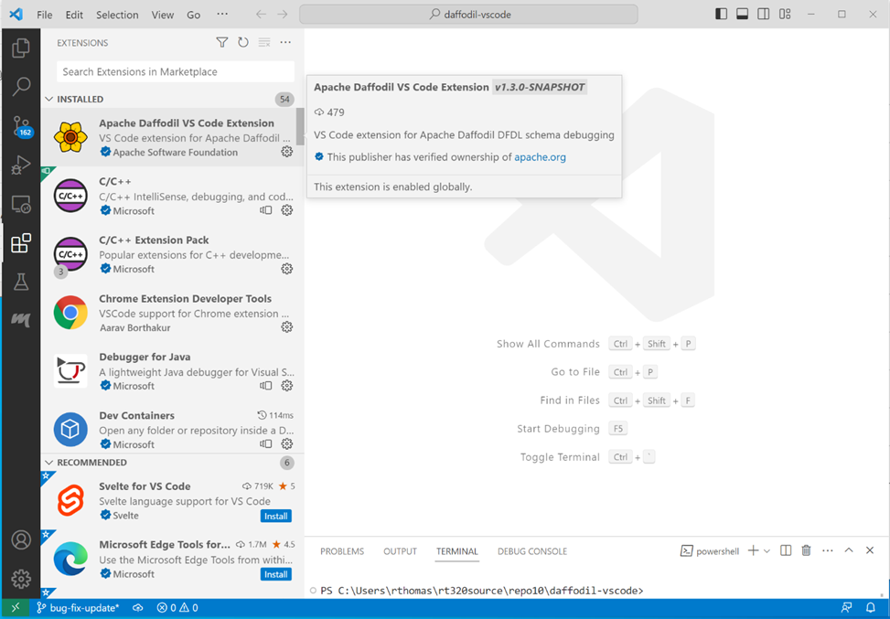

image

Install the Apache Daffodil VS Code Extension from the VS Code Marketplace.

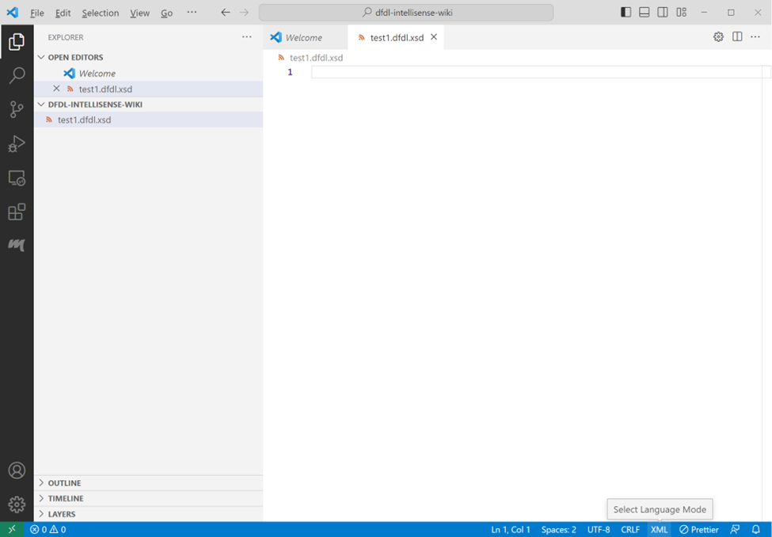

image

Open a schema file in the editor and set the language mode located in the bottom right corner to dfdl.

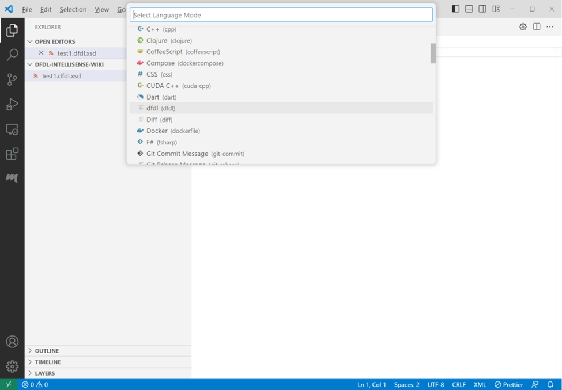

image

Click the language in the bottom right of the status bar or type Ctrl+Shift+p and enter ‘language mode’, then select dfdl from the list of available languages.

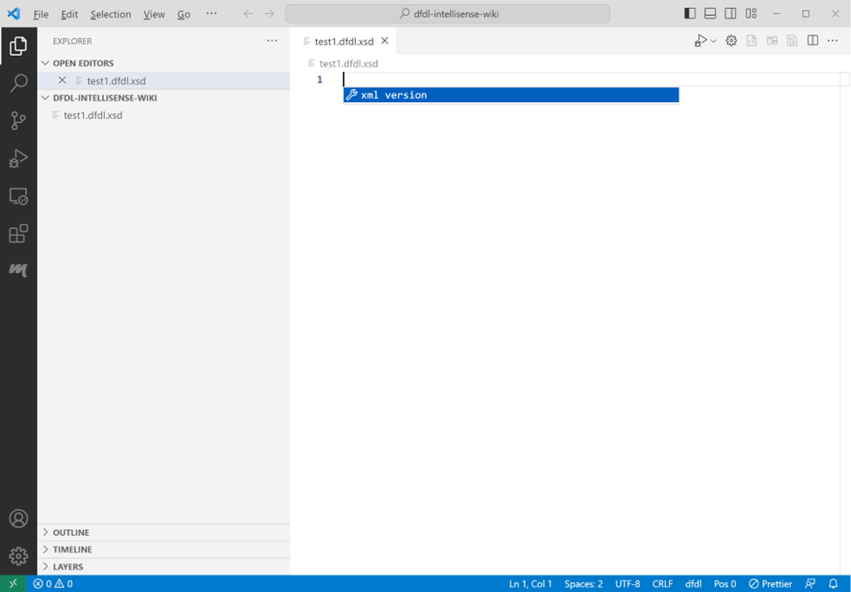

image

Press ctrl+space in the empty editor window. The XML version declaration should appear as the only choice. Select that choice by pressing the enter key.

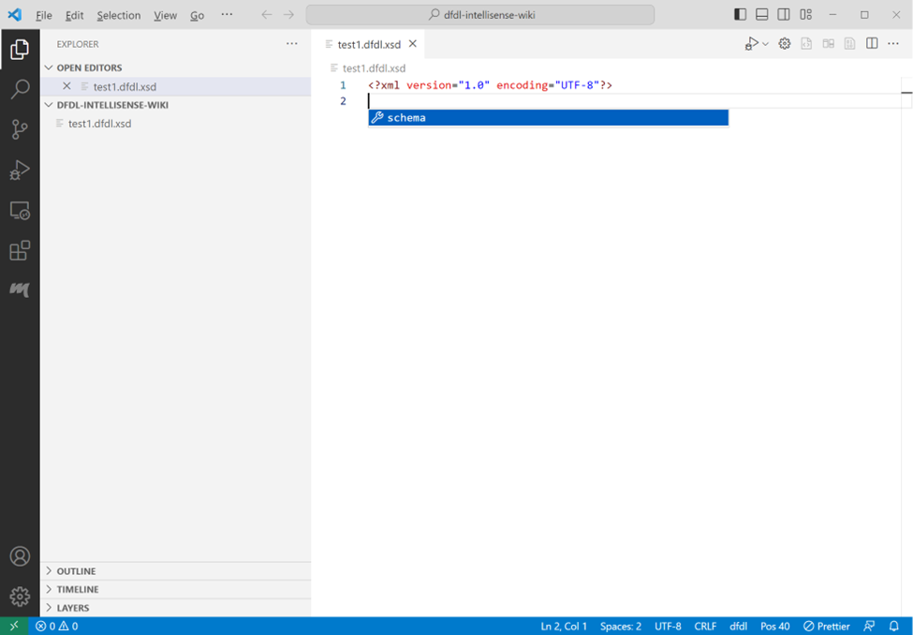

image

Press ctrl+space again and the schema choice will show. Press enter to accept the schema choice.

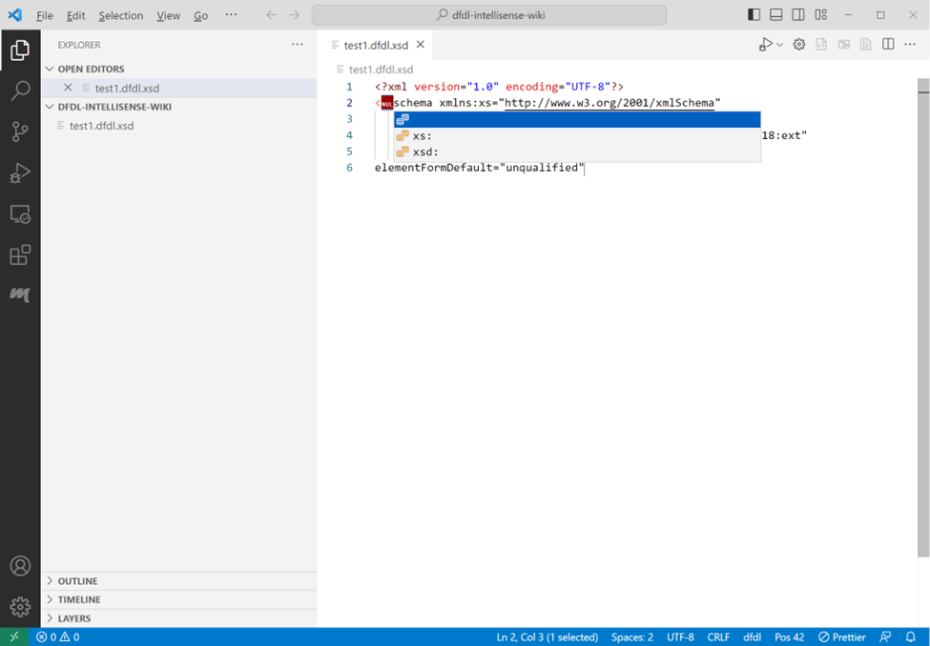

image

Select nul, or one of the other choices in the choice list. If you select nul for no namespace, you will need to backspace over the null character to remove it. If you want to type in a different namespace choice, remove null and type in your namespace choice followed by a colon ‘:’. If you select a namespace option here, it will be used throughout the schema as a namespace prefix to standard XML elements. The dfdl namespace prefix will automatically be added to dfdl elements. After selecting or writing in a namespace option, press the tab key to move to the end of the schema tag block.

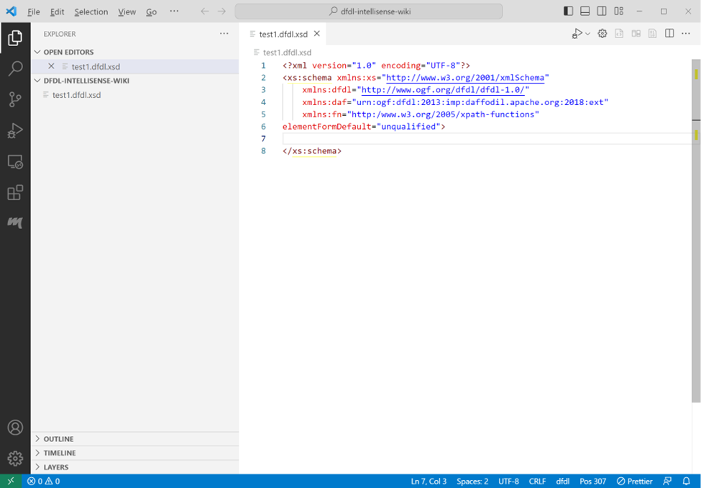

image

At the end of the schema tag block, you can type ‘>’ to auto-end the schema block. Intellisense will place the end tag character on the schema open tag block, create the schema closing tag, and position the cursor between the tags.

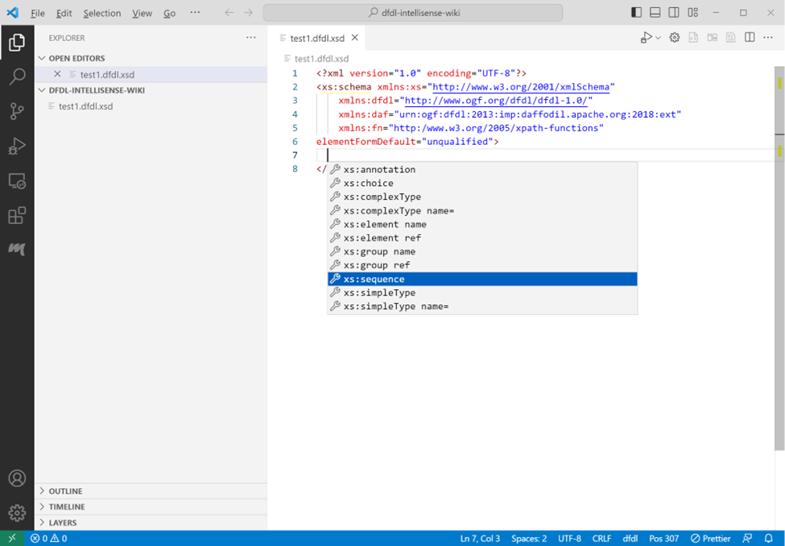

image

Press ctrl+space to get a list of element type choices available within the schema tags. Select a choice and press enter.

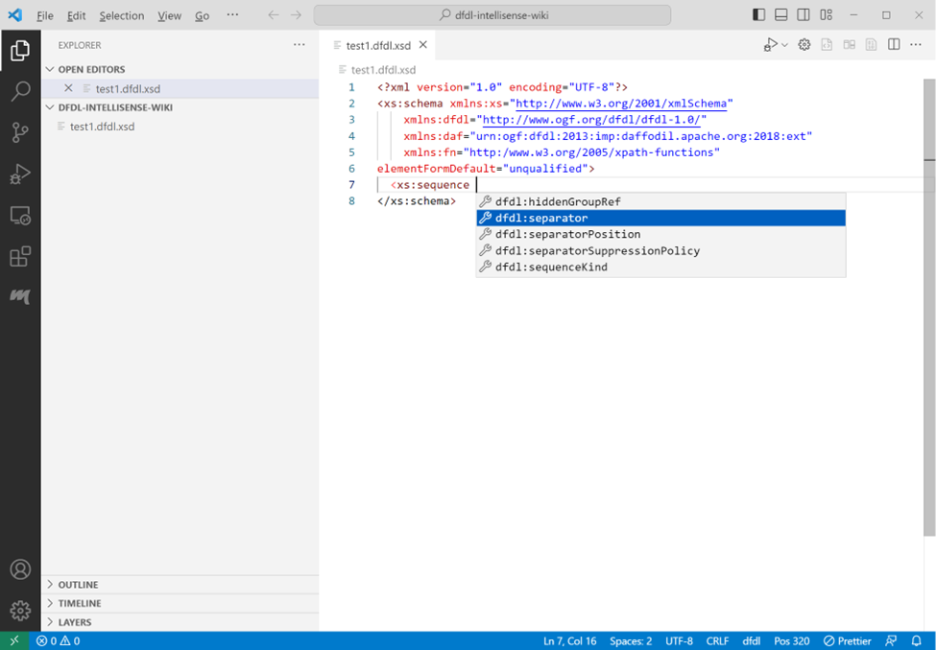

image

Attributes can be supplied in the sequence open tag. To get a list of attribute choices press space at the cursor position. Intellisense will open a menu that allows a selection of an attribute. If the attribute has predetermined choices a list of those will appear after the attribute is selected.

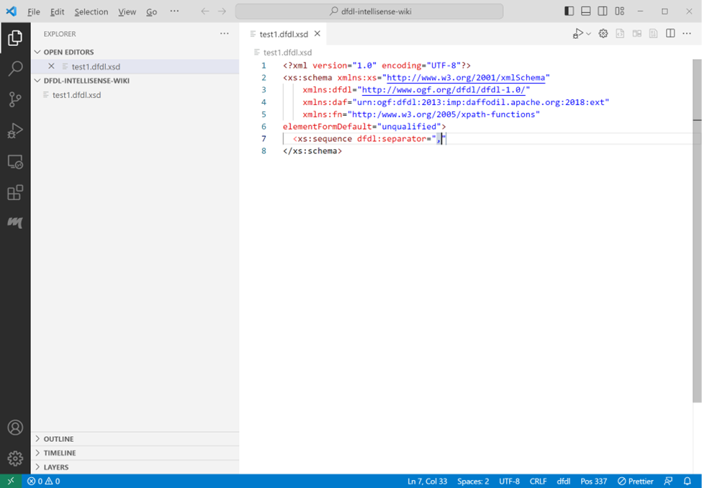

image

The separator attribute doesn’t have a specific list of choices. The comma was manually entered to provide a value to the field. Press tab to exit the double quotes. The cursor will be positioned immediately after the ending double quote.

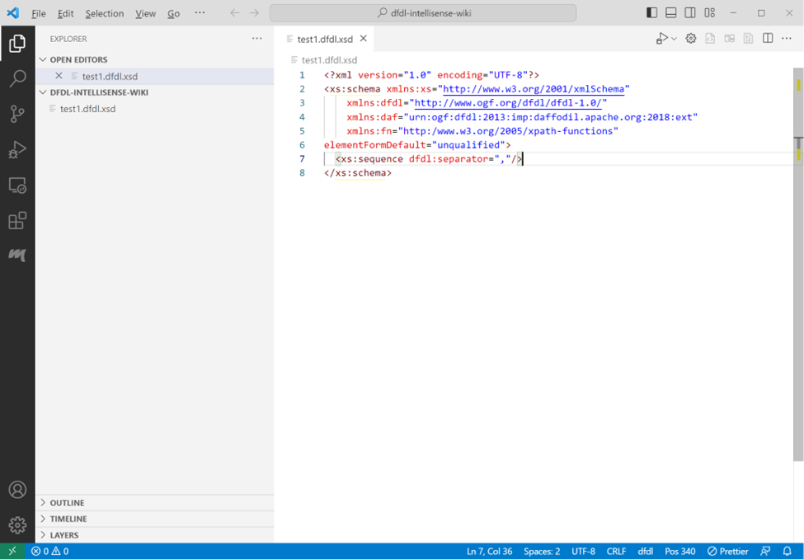

image

Type space again to choose another attribute, or type / to create a self-closing tag. After typing a slash to close the tag, the cursor will be positioned at the end of the tag. Press enter to continue on the next line.

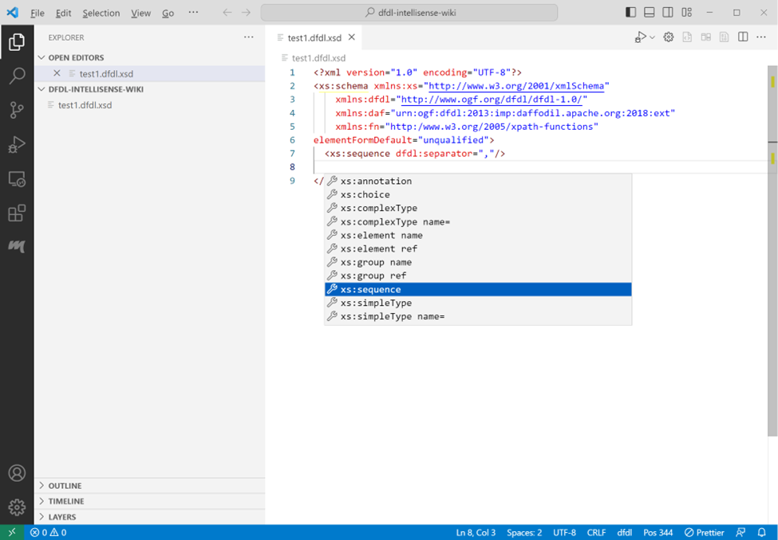

image

Press ctrtl+space to get a list of element choices.

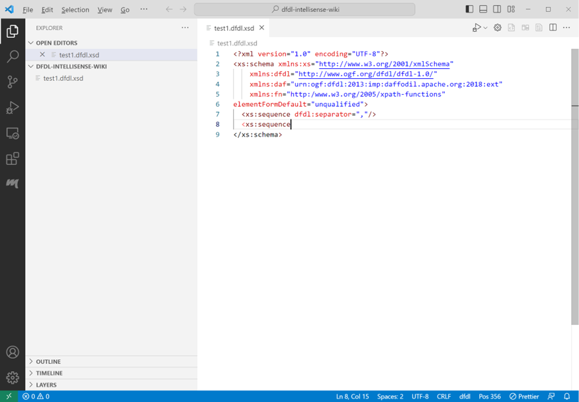

image

A tag can also be closed by typing ‘>’ at the cursor position after the tag.

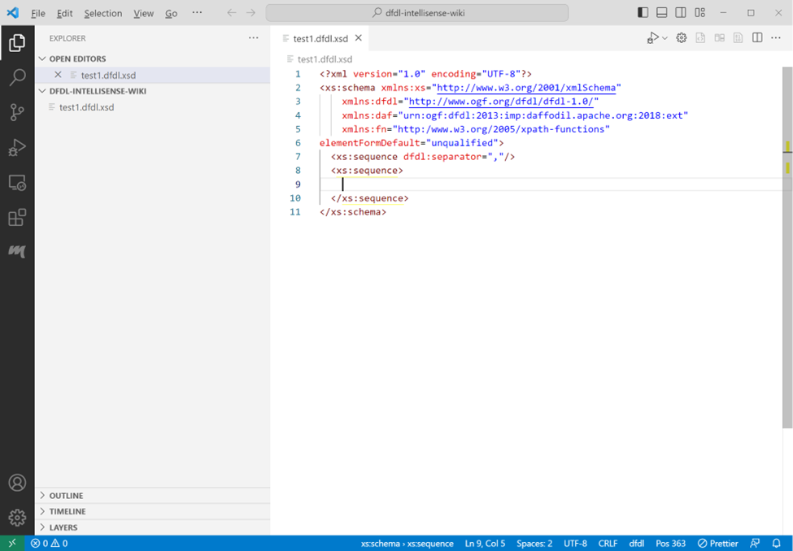

image

Closing a tag with a ‘>’ will normally result in a closing tag on a new line and the cursor positioned between the two tags. (If an open tag is split over multiple lines, the closing tag is not moved to the next line. This behavior can be changed based on community input).

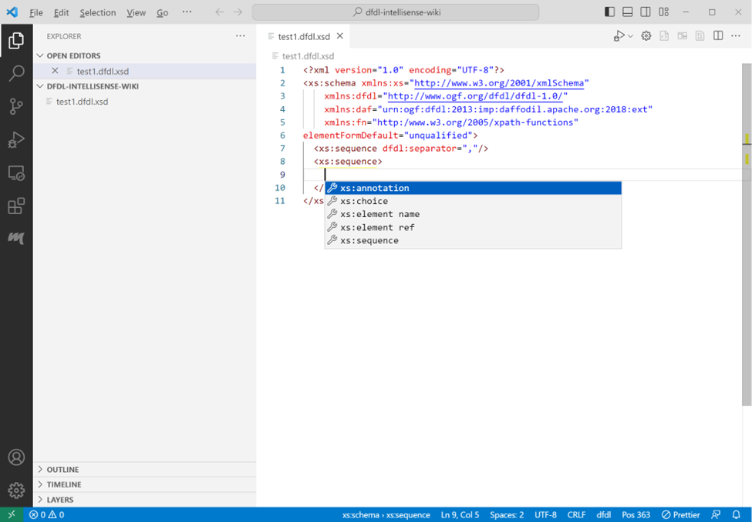

image

Press ctrl+space on the empty line to get a list of element choices available between tags.

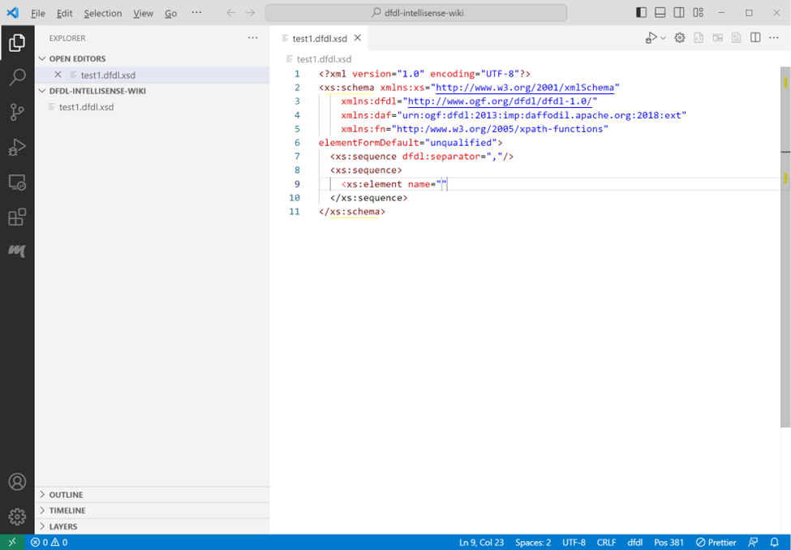

image

Select a choice by pressing enter. In this example the element tag with the attribute name was selected and a value for name entered. Press tab to exit the double quotes after entering a name value. The name attribute doesn’t have a specific list of choices.

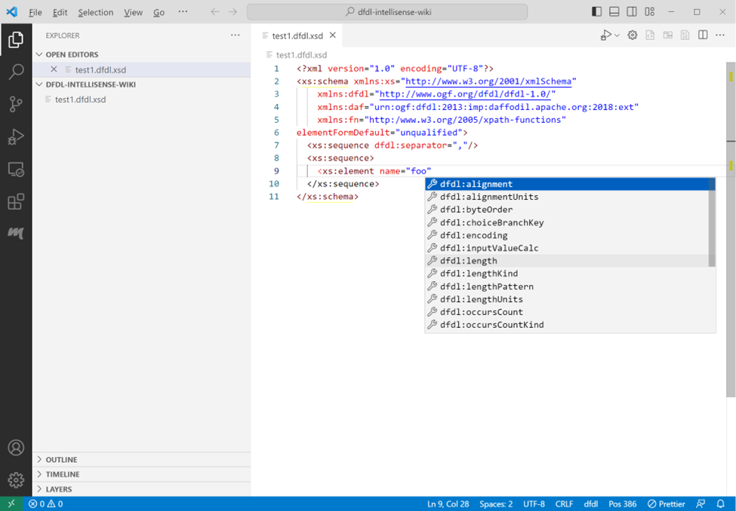

image

Type ctrl+space to get a list of attribute choices for the element tag.

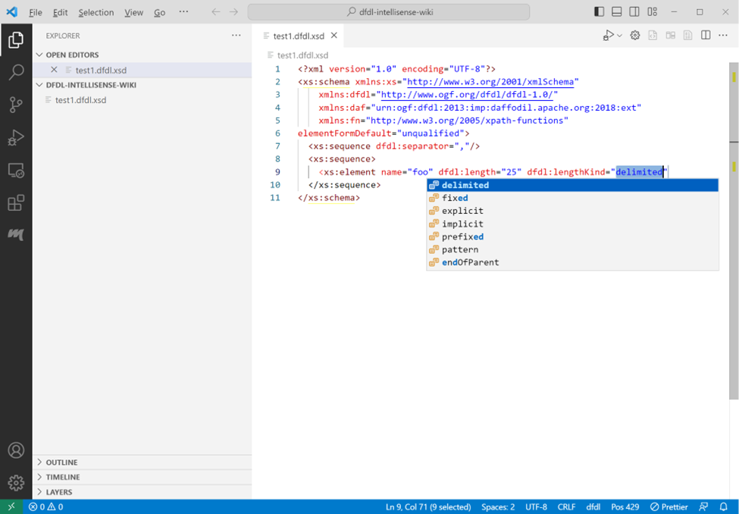

image

Selecting an attribute that has predetermined choices will supply a list of those choice. Select an item from the list and press enter. End the tag with ‘>’ to get a closing tag on a new line with the cursor positioned between the tags.

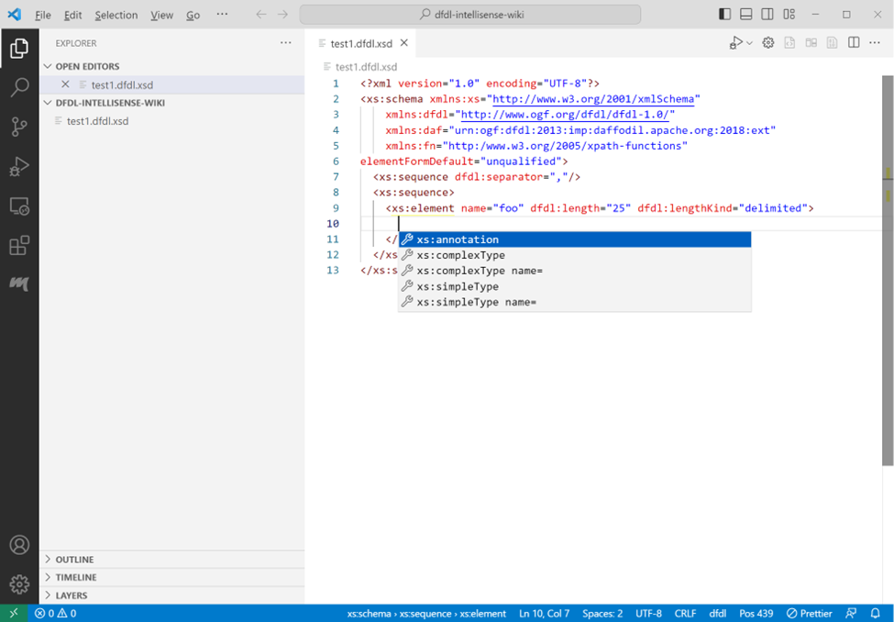

image

On the new line press ctrl+space to get a list of element choices for the element tag.

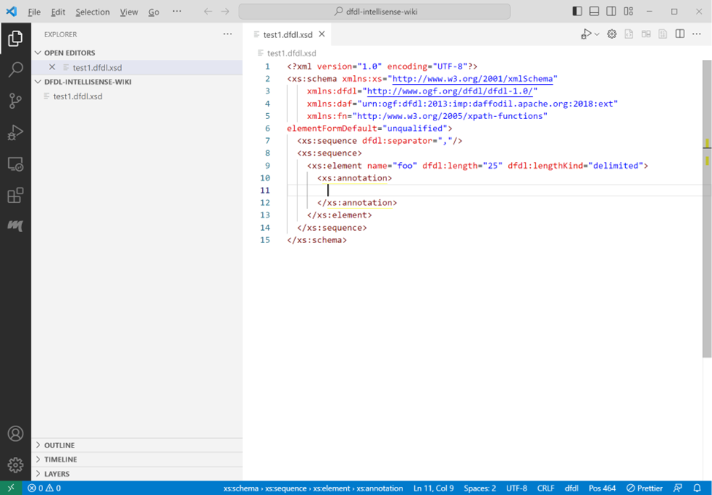

image

Select a choice and press ctrl+space to get list of choices for the selected annotation tag set.

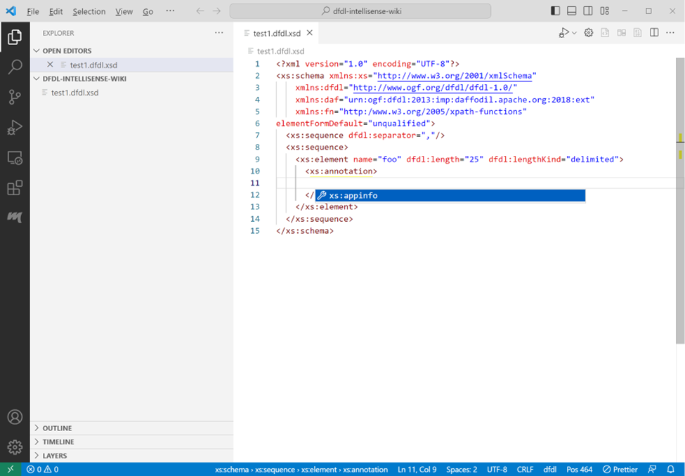

image

Select a choice and press ctrl+space to supply a list of choices available in the appinfo tag set.

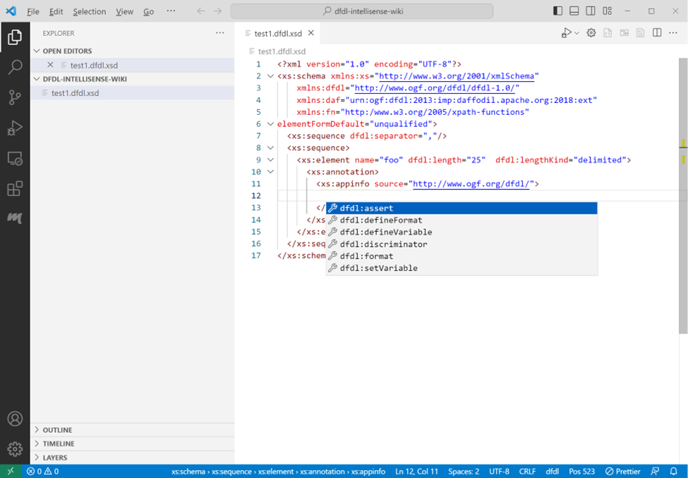

image

Select a choice by pressing enter.

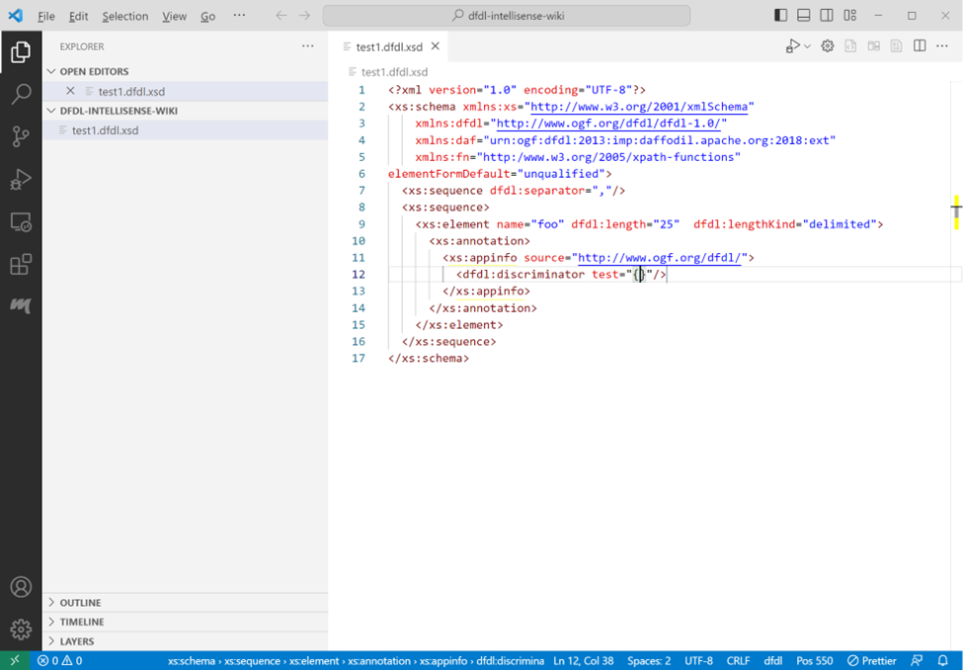

image

The discriminator test dfdl attribute doesn’t have a specific list of choices. Press tab to exit the double quotes. The cursor will be positioned immediately after the ending double quote.

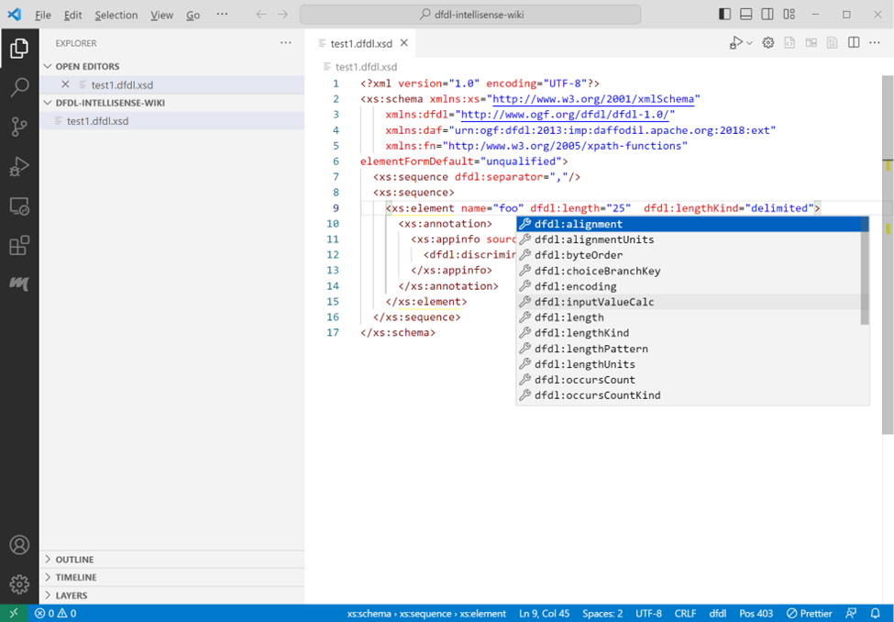

image

To add additional attributes to an existing element tag, position the cursor within the opening tag, press ctrl+space, or space to get a list of attribute choices for that tag.

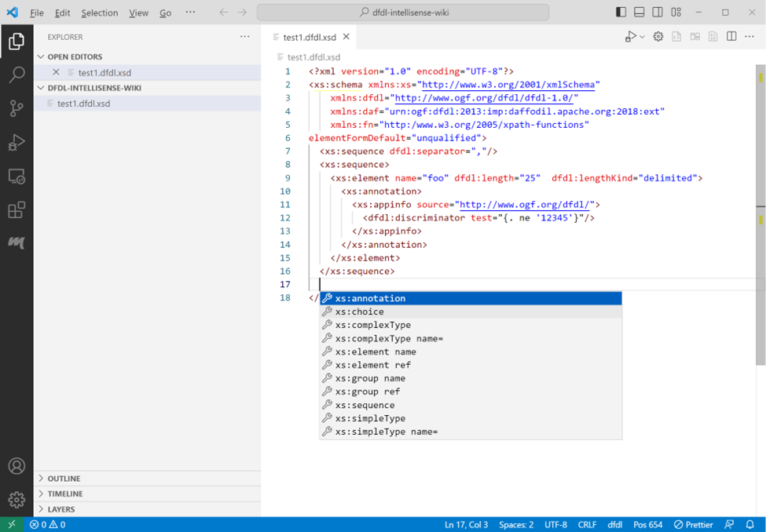

image

Adding a new line anywhere in the schema and pressing ctrl+space will provide a list of choices available between the tags at the current position.

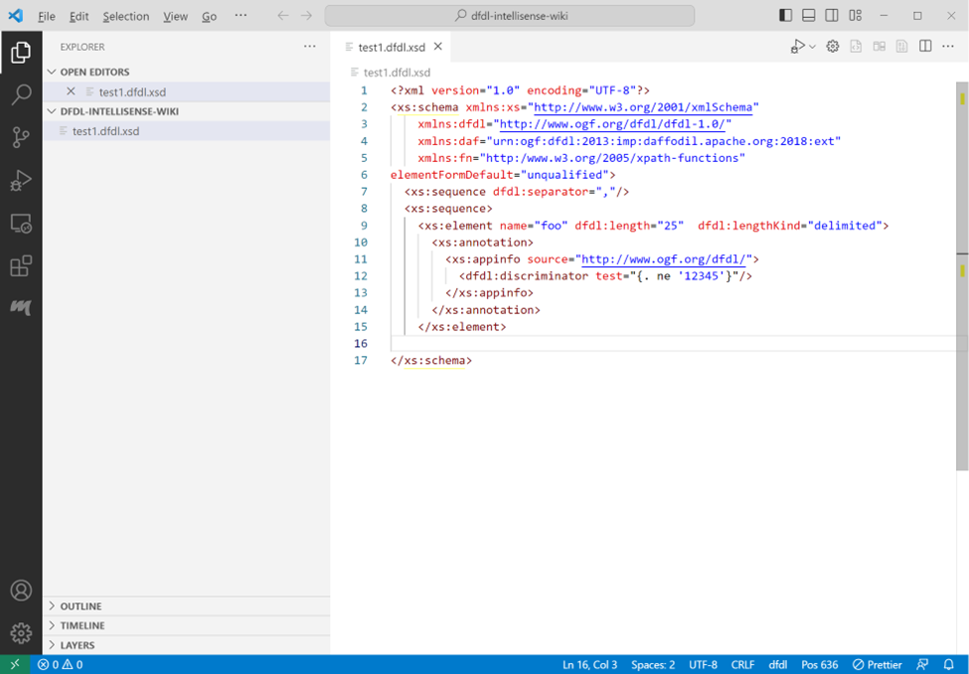

image

If a closing tag is deleted or missing, type ‘>’ to re-add the closing tag at the cursor position.

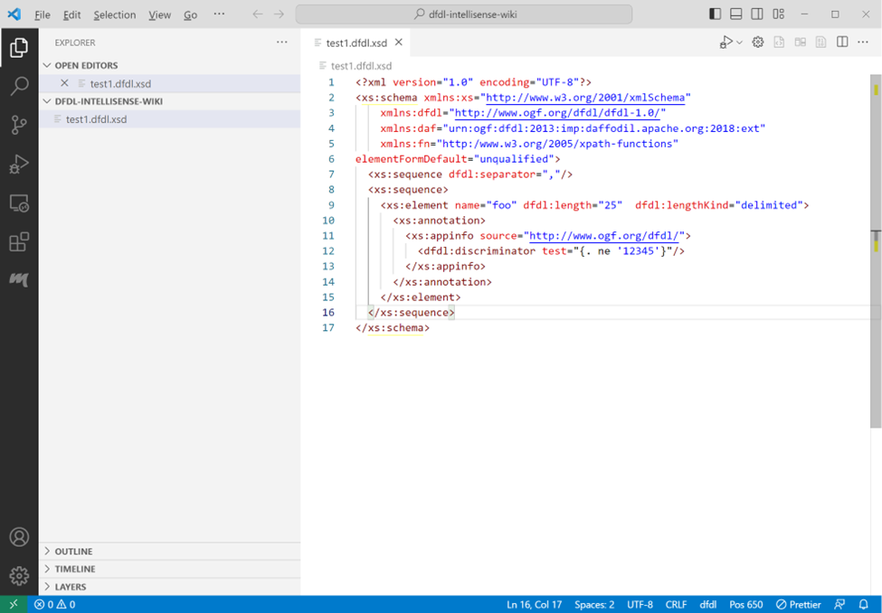

image

The closing tag will be re-added and cursor will be placed at the end of the line.

XPath expressions can be code completed.

## Known Issues With Code Completion

1. The Apache Daffodil™ Extension for Visual Studio Code uses a clunky method to auto complete curly braces within quotes. It is anticipated that this will be better addressed in the future. The auto complete method blocks suggestions while typing between the beginning quote, opening curly brace and the closing curly brace, ending quote.

# Debugging a DFDL Schema Using Data Parse Debugger

## Debug Configuration

Debugging a DFDL Schema needs both the DFDL Schema to use and a data file to parse. Instead of having to select the DFDL Schema and the data file each time from a file picker, a “launch configuration” can be created, which is a JSON description of the debugging session.

A launch configuration can be created using the Launch Wizard or done manually through the ./vscode/launch.json file

### Launch Wizard Configuration

The launch wizard can be accessed two ways, either from the edit window when editing a DFDL schema file as shown below

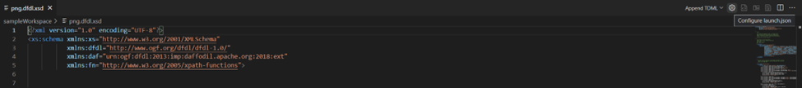

image

Or it can be accessed through the Command Palette (Ctrl + Shift + P) and search for Configure launch.json 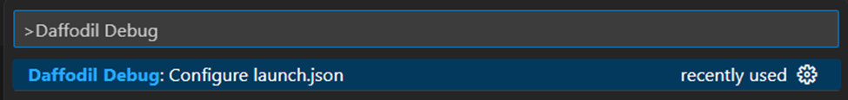

A new tab will be created with the Launch Config Wizard

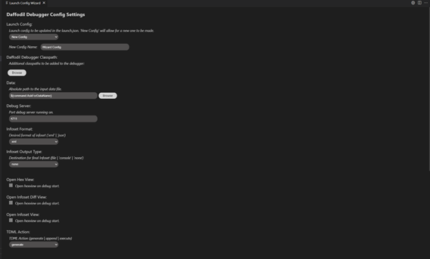

image

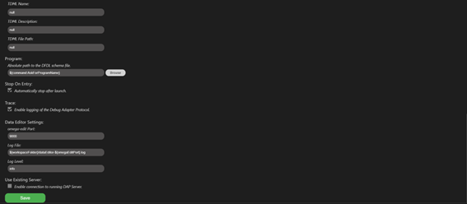

image

Here you can create or edit Daffodil Debugger Config Settings

The drop down under Launch Config will allow you to create a new config and name it or you can select an already created config from the drop down.

The Daffodil Debugger Classpath is for additional classpaths that you would like the debugger to retrieve files from. Use ${workspaceFolder} for files in the VS Code workspace, and use absolute paths for files outside of the workspace.

Under the Data section, you can specify an absolute path to the data input file or leave it as a command and the debugger will ask you each time you run it.

The Debug Server specifies the port that the debug server should be running on.

The Infoset Format gives the user the ability to have their infosets generated as a XML or JSON format.

The Infoset Output Type gives the user the ability to specify a destination for their infoset file being a file placed at the path given by the user, printed out in console, or none for no output of an infoset.

The three checkboxes will open each of the additional views upon running the debugger, those are the

Hex View – Shows daffodil schema in a datafile-hex view

Infoset Diff View – Shows a side-by-side diff of the previous and current infoset file

Infoset View – Shows the infoset file being created in real time as the debugger runs

The TDML Action section allows the user to specify whether a TDML file should be generated, appended to the end of a previously created TDML file, or should not be created.

If set to generate or append, a TDML file name, description, and file path must be given.

Under Program, an absolute path can be given to the DFDL schema file leave it as a command and the debugger will ask you each time you run it.

The Stop On Entry checkbox will make the debugger automatically pause after launching. This allows the user to set breakpoints before running the file through.

The Trace checkbox enables the logging of the Debug Adapter Protocol.

Under Data Editor Settings, there is configurations for [Omega Edit](https://github.com/ctc-oss/omega-edit), here you can specify the port, log file location, and log level.

The Use Existing Server check box will enable a connection to a Debug Adapter Protocol (DAP) Server

Once all configurations have been completed, they can be saved and a launch.json file will be created.

### Manual Launch Configuration

1. Select Run -> Open Configurations from the VS Code menubar. This will load a launch.json file into the editor. There may be existing configurations, or it may be empty.
2. Press Add Configuration... and select the Daffodil Debug - Launch option.

Once the launch.json file has been created it will look something like this

{  
 "type": "dfdl",  
 "request": "launch",  
 "name": "Ask for file name",  
 "program": "${command:AskForProgramName}",  
 "stopOnEntry": true,  
 "data": "${command:AskForDataName}",  
 "infosetOutput": {  
 "type": "file",  
 "path": "${workspaceFolder}/infoset.xml"  
 },  
 "debugServer": 4711  
}

This default configuration will prompt the user to select the DFDL Schema and data files. If desired, the “program” and “data” elements can be mapped specifically to the user’s files to avoid being prompted each time.

📝 Note: Use ${workspaceFolder} for files in the VS Code workspace, and use absolute paths for files outside of the workspace.

{  
 "type": "dfdl",  
 "request": "launch",  
 "name": "DFDL parse: My Data",  
 "program": "${workspaceFolder}/schema.dfdl.xsd",  
 "stopOnEntry": true,  
 "data": "/path/to/my/data",  
 "infosetOutput": {  
 "type": "file",  
 "path": "${workspaceFolder}/infoset.xml"  
 },  
 "debugServer": 4711  
}

## Launch a DFDL Parse Debugging Session

Using the launch profile above a DFDL parse: My Data menu item at the top of the Run and Debug pane (Command-Shift-D) will display. Then press the play button to start the debugging session.

In the Terminal, log output from the DFDL debugger backend service will display. If something is not working as expected, check the output in this Terminal window for hints.

The DFDL Schema file will also be loaded in VS Code and there should be a visible marking at the beginning where the debugger has paused upon entry to the debugging session. Control the debugger using the available VS Code debugger controls such as setting breakpoints, removing breakpoints, continue, step over, step into, and step out.

## Other Options for Launching a DFDL Parse Debugging Session

* **Option 1:**
  + Open the DFDL Schema file to debug
  + From inside the file open the Command Palette (Mac = Command+Shift+P, Windows/Linux = Ctrl+Shift+P)
  + Once the command Palette is opened start typing Daffodil Debug:
    - Option 1 = Daffodil Debug: Debug File - This will allow for the user to fully step through the DFDL Schema. Once fully completed, it will produce an infoset to a file named SCHEMA-infoset.xml which it then opens as well.
    - Option 2 = Daffodil Debug: Run File - This will run the DFDL Schema, producing the infoset to a file named SCHEMA-infoset.xml.
* **Option 2:**
  + Open the schema file to debug
  + Click the play button in the top right, two options will be provided:
    - Option 1 = Debug File - This will allow for the user to fully step through the schema (WIP). Once fully completed, it will produce a infoset to a file named SCHEMA-infoset.xml which it then opens as well.
    - Option 2 = Run File - This will run the DFDL Schema, producing the infoset to a file named SCHEMA-infoset.xml which it then opens as well.

## Custom DFDL Debugger Views

### Infoset Tools

Find the infoset tools from the command menu (Mac = Command+Shift+P, Windows/Linux = Ctrl+Shift+P)

### Inputstream Hex Viewer

Find the hex view from the command menu (Mac = Command+Shift+P, Windows/Linux = Ctrl+Shift+P)

# Data Editor

This version of the Apache Daffodil™ Extension for Visual Studio Code includes a new Data Editor. To use the Data Editor, open the VS Code command palette and select Daffodil Debug: Data Editor.

A notification message will appear that informs where the Data Editor will write its logs to. If problems happen, check this log file for clues.

Once the extension is connected to the server, the bottom left corner of the Data Editor shows the version of the Ωedit server powering the editor, and the port its connected to. Hovering over the filled circle shows the CPU load average, the memory usage of the server in bytes, the server session count, the server uptime measured in seconds, and the round trip latency measured in milli-seconds.

After selecting a file to edit, there will be a table with controls at the top of the Data Editor.

The first section of the table is called File Metrics and it contains the path of the file being edited, its initial size in bytes, and the size as the file is being edited. When changes are committed, the Save button will become enabled, allowing the changes to be saved to file.

The second section of the table is called Search, and it allows for Searching of byte sequences in the given Edit Encoding. If the Edit Encoding can be case-insensitive, a Case Insensitive checkbox will be displayed allowing for that option to be enabled. The found sequences can be examined using the Prev and Next buttons found in this section. Found sequences can also be replaced in the given Edit Encoding by filling in a replacement sequence. Currently *all* the sequences will be replaced.

The third section of the table is called Settings, and it allows for toggling the Byte Edit Mode from Single to Multiple.

In Single byte edit mode, individual bytes may be *deleted*, *inserted* (to the left or to the right of the selected byte), and *overwritten* in the Ephemeral Edit Window that appears when a byte in the Physical or Logical viewports is clicked. Mouseover the buttons of the Ephemeral Edit Window to determine what each button does. Mouseover the Input Box and it will show the byte offset position in the selected Address Radix. Buttons will become enabled or disabled depending on whether there is valid input in the Input Box or not. Values entered in the Input Box must match the format set by the byte display radix when editing bytes in the Physical viewport or be in Latin-1 (8-bit ASCII) format when editing bytes in the Logical viewport.

In Multiple byte edit mode, a segment of bytes is selected from either the Physical or Logical viewports, then the selected segment of bytes is edited in the Edit viewport using the selected Edit Encoding. Once editing of the selected segment is completed, the Commit button is pressed, and the edited segment replaces the selected segment

Byte addresses can be expressed in hexadecimal, decimal, or octal. The selected Address Radix is also what is used entering an offset into the Offset input. If an offset was entered in the Offset input and the Address Radix is changed, the offset will automatically be converted into the selected radix.

In Single byte edit mode, byte editing can be done in the Physical viewport, or the Logical viewport. The Physical viewport shows the bytes as they are stored in the file and can be represented in Hexadecimal, Decimal, Octal, or Binary depending on the Byte Display Radix. The Logical viewport always shows the bytes as Latin-1. The Data View shows the integer and floating point values of the bytes starting at the selected address. The values in the Data View will be expressed in the selected Endianness (Little or Big).

In Multiple byte edit mode, byte editing can only be done in the Edit viewport using a selection of bytes from the Physical or Logical viewports. The Edit viewport shows the bytes represented in Hexadecimal, Binary, ASCII, Latin-1, UTF-8, or UTF-16LE (UTF-16 Little Endian), depending on the Edit Encoding. Once the editing of that segment is done, the Commit button is pressed, and the edited segment replaces the selected segment in the Physical and Logical viewports.

Regardless of the Byte Edit Mode, changes can be Undoed and Redone using the Undo and Redo buttons. The Revert All button will revert all changes made to the file since it was opened in the Data Editor.

The Data Editor supports light and dark modes. The mode is determined by the VSCode theme. If the VSCode theme is set to a light theme, the Data Editor will be in light mode. If the VSCode theme is set to a dark theme, the Data Editor will be in dark mode.

### Data Editor Launch Settings

Users can update the settings for the Data Editor using the launch config file (.vscode/launch.json). The way to add these settings is by doing something like:

{  
 "version": "0.2.0",  
 "configurations": [  
 {  
 ...  
 "dataEditor": {  
 "port": 9001,  
 "logFile": "/tmp/dataEditor-9001.log",  
 "logLevel": "debug"  
 }  
 }  
 ]  
}

If one or more of these items are not set, the items will be set to their default values. Below are the default values:

"dataEditor": {  
 "port": 9000,  
 "logFile": "${workspaceFolder}/dataEditor-${omegaEditPort}.log",  
 "logLevel": "info"  
}

### Data Editor Limitations in v1.3.0

1. The current editing limit is 1,000,000 bytes. This is due to the amount of memory it takes to encode and display all the bytes in the viewports.
2. Only one Data Editor instance can be opened at one time.
3. Viewport selections do not persist when they lose focus. This is a limitation of implementing the display viewports using textarea elements.
4. Currently Replace will replace *all instances* of the given search pattern with the replacement pattern.

As of v1.3.0, this feature is *minimally viable* and will be improving over time. Expect these limitations to be removed in the next release.

📝 Note: The non-printable font being used (░) may appear different on different platforms and OS/font configurations.

# TDML Support

To Generate a TDML file, use similar steps for Launching a DFDL Parse Debugging Session: * Open the DFDL Schema file * From inside the file, open the Command Palette (Mac = Command+Shift+P, Windows/Linux = Ctrl+Shift+P) * Once the Command Palette is opened, select the Daffodil Debug: Generate TDML command * From there, you will be asked to provide the input data file, the TDML test case name, the TDML test case description, and the location/name for the TDML file.

Once the Daffodil Parse has finished, an infoset and a TDML file will be created. The TDML file contains relative paths to the DFDL Schema file, input data file, and infoset file. When creating an archive for these files, preserve the directory structure in the archive.

To Append a new test case to an existing TDML file, use similar steps for Generating a TDML file: * Open the DFDL Schema file * From inside the file, open the Command Palette (Mac = Command+Shift+P, Windows/Linux = Ctrl+Shift+P) * Once the Command Palette is opened, select the Daffodil Debug: Append TDML command * From there, you will be asked to provide the input data file, the TDML test case name, the TDML test case description, and the TDML file

Once the Daffodil Parse has finished, an infoset will be created, and a test case will be added to the existing TDML file. The TDML test case name OR description can be shared between test cases, but no two test cases should share TDML test case names and descriptions. To create an archive for a TDML file with multiple test cases, the same guidelines for creating an archive from a TDML file created from a ‘Generate TDML’ operation should be followed. All DFDL schema files, input data files, the TDML file, and, optionally, the infosets should be added to the archive. Additionally, any directory structure should be preserved in the archive to allow for the relative paths in the TDML file to be resolved.

When running a zip archive created from another user, extract the archive into your workspace folder. If there is an infoset in the zip archive that you wish to compare with your infoset, make sure that the infoset from the zip archive is not located at the same place as the default infoset for the Daffodil Parse that will be run when executing a test case from the TDML file. This is because the Daffodil Parse run by executing the TDML test case uses the default location for its infoset and will overwrite anything that already exists there.

To Execute a test case from a TDML file, use the following steps: * Open a DFDL Schema file * From inside the file, open the Command Palette (Mac = Command+Shift+P, Windows/Linux = Ctrl+Shift+P) * Once the Command Palette is opened, select the Daffodil Debug: Execute TDML command * From there, you will be asked to provide the TDML file, TDML test case name, and TDML test case description

A Daffodil Parse will then be launched. The DFDL Schema file and input data file to be used is determined by the selected test case in the TDML file. The infoset that is generated from this parse can optionally be compared to an infoset included in the zip archive the TDML file was extracted from.

## Sample TDML File

A TDML file is comprised of Test Cases. Each test case describes a DFDL parse operation and points to the inputs and outputs of the DFDL parse operation. Inputs - DFDL Schema file and input data file Outputs - Infoset file

Additionally, each Test Case should be uniquely identified by the combination of its name and description. Currently, this is not enforced, and any duplications will never be selectable by the TDML Execute operation.

Below is a Sample TDML file with a single Test Case along with XPath expressions describing where each item can be found inside of a Test Case.

<?xml version="1.0" encoding="UTF-8" standalone="yes"?>  
<ns1:testSuite xmlns:ns1="http://www.ibm.com/xmlns/dfdl/testData" xmlns:ns2="http://www.ogf.org/dfdl/dfdl-1.0/" xmlns:ns3="urn:ogf:dfdl:2013:imp:daffodil.apache.org:2018:ext" xmlns:ns4="http://www.ogf.org/dfdl/dfdl-1.0/extensions" xmlns:xs="http://www.w3.org/2001/XMLSchema" xmlns:ns6="urn:ogf:dfdl:2013:imp:daffodil.apache.org:2018:int" suiteName="Default Test Case" defaultRoundTrip="onePass">  
 <ns1:parserTestCase name="Default Test Case" root="file" model="png.dfdl.xsd" roundTrip="onePass" description="Generated by DFDL VSCode Extension">  
 <ns1:document>  
 <ns1:documentPart type="file">di4zg8Kie.png</ns1:documentPart>  
 </ns1:document>  
 <ns1:infoset>  
 <ns1:dfdlInfoset type="file">png-infoset.xml</ns1:dfdlInfoset>  
 </ns1:infoset>  
 </ns1:parserTestCase>  
</ns1:testSuite>

/ns1:testSuite/ns1:parserTestCase/@model contains the relative path to the DFDL Schema file. This path is relative to the location of the TDML file  
/ns1:testSuite/ns1:parserTestCase/@name contains the name of the Test Case  
/ns1:testSuite/ns1:parserTestCase/@description contains a description of the Test Case  
/ns1:testSuite/ns1:parserTestCase/ns1:document/ns1:documentPart/text() contains the relative path to the input data file. This path is relative to the location of the TDML file  
/ns1:testSuite/ns1:parserTestCase/ns1:infoset/ns1:dfdlInfoset/text() contains the relative path to the infoset file created with the parameters of this test case. This path is relative to the location of the TDML file

# Reporting Problems and Requesting New Features

If problems are encountered or new features are desired, create tickets [here](https://github.com/apache/daffodil-vscode/issues).

# Getting Help

If additional help or guidance on using Daffodil and its tooling is needed, please engage with the community on [mailing lists](https://daffodil.apache.org/community/) and/or review the [archives](https://lists.apache.org/list.html?users@daffodil.apache.org).

# Additional Resources

* [Apache Daffodil™ Extension for Visual Studio Code Wiki](https://github.com/apache/daffodil-vscode/wiki)
* [Apache Daffodil Repository](https://github.com/apache/daffodil)

# Apache Daffodil™ Extension for Visual Studio Code

The Apache Daffodil™ Extension for Visual Studio Code is an extension to the Microsoft® Visual Studio Code (VS Code) editor which enables Data Format Description Language (DFDL) syntax highlighting, code completion, and the interactive debugging of DFDL Schema parsing operations using [Apache Daffodil™](https://daffodil.apache.org/).

DFDL is a data modeling language used to describe file formats. The DFDL language is a subset of eXtensible Markup Language (XML) Schema Definition (XSD). Just as file formats are rich and complex, so is the modeling language to describe them. Developing DFDL Schemas can be challenging, requiring a lot of iterative development, and testing.

The purpose of Apache Daffodil™ Extension for Visual Studio Code is to ease the burden on DFDL Schema developers, enabling them to develop high quality, DFDL Schemas, in less time. VS Code is free, open source, cross-platform, well-maintained, extensible, and ubiquitous in the developer community. These attributes align well with the Apache Daffodil™ project and the Apache Daffodil™ Extension for Visual Studio Code.

## Bundled Tools in the Apache Daffodil™ Extension for Visual Studio Code

### DFDL Syntax Highlighting

DFDL is rich and complex. Developers using modern code editors expect some degree of built-in language support for the language in which they are developing, and DFDL should be no different. The Apache Daffodil™ Extension for Visual Studio Code provides syntax highlighting to improve the readability and context of the text. In addition, the syntax highlighting provides feedback to the developer indicating the structure and code appear syntactically correct.

### DFDL Schema Code Completion

The Apache Daffodil™ Extension for Visual Studio Code provides code completion, also known as “Intellisense”, offering context-aware code segment predictions that can dramatically speed up DFDL Schema development by reducing keyboard input, memorization by the developer, and typos.

### Daffodil Data Parse Debugger

The Apache Daffodil™ Extension for Visual Studio Code provides a Daffodil Data Parse Debugger which enables the developer to carefully control the execution of Apache Daffodil™ parse operations. Given a DFDL Schema and a target data file, the developer can step through the execution of a parse line by line, or until the parse reaches some developer-defined location, known as a break point, in the DFDL Schema. What is particularly helpful is that the developer can watch the parsed output, known as the “infoset”, as it’s being created by the parser, and see where the parser is parsing in the data file. This enables the developer to quickly discover and correct issues, improving DFDL Schema development and testing cycles.

### Data Editor

The Apache Daffodil™ Extension for Visual Studio Code provides an integrated data editor. It is akin to a hex editor, but tuned specifically for challenging Daffodil use cases. As an editor designed for Daffodil developers by Daffodil developers, features of the tool will evolve quickly to address the specific needs of the Daffodil community.

# Prerequisites

This guide assumes VS Code and a Java Runtime Environment (Java 8 or greater) are installed.

* [Install VS Code](https://code.visualstudio.com/download)
* [Install Java Runtime 8 or greater](https://docs.oracle.com/goldengate/1212/gg-winux/GDRAD/java.htm#BGBFJHAB)
* On Linux, glibc 2.31 or greater is required

# Installing the Apache Daffodil™ Extension for Visual Studio Code

The Apache Daffodil™ Extension for Visual Studio Code can be installed using one of two methods.

## Option 1: Install the Apache Daffodil™ Extension for Visual Studio Code From the Visual Studio Code Extension Marketplace

The Apache Daffodil™ Extension for Visual Studio Code is available in the [Visual Studio Code Extension Marketplace](https://marketplace.visualstudio.com/vscode). This option is recommended for most users.

## Option 2: Install the Latest .Vsix File From the Apache Daffodil™ Extension for Visual Studio Code Release Page

The latest .vsix (the file extension used for VS Code extensions) file can also be downloaded from the Apache Daffodil™ Extension for Visual Studio Code [releases page](https://github.com/apache/daffodil-vscode/releases) and installed by either:

* Using the command-line via code --install-extension <path-to-downloaded-vsix-file>; or
* Using the “Extensions: Install from VSIX” command from within VS Code by opening the Command Palette (Mac = Command+Shift+P, Windows/Linux = Ctrl+Shift+P), and typing vsix to bring up the command and pointing it at the downloaded .vsix file.

# DFDL Schema Authoring Using Code Completion

## Set the Editor to “dfdl” mode

Since DFDL Schema files end with .xsd (XML Schema Definition or XSD), the editor needs to be informed specifically that DFDL mode is desired over the more general XML mode. The mode is selected in the status bar at the bottom of the editor window.

## DFDL Schema Authoring Features

Auto suggest is triggered using control space or typing the beginning characters of an item. Typing one or more unique characters will further limit the results.

📝 **NOTE:** Intellisense is *context aware*, so there is no need to begin a block with <, just start typing the tag name and code completion will automatically handle it as appropriate.

Code completion can be used to add a schema block, with just a couple of keystrokes. Code completion can make short work out of completing a DFDL Format Block, offering context-sensitive suggestions attribute values.

The > or / characters are used to close XML tags. Use tab to select an item from the drop down and to exit double quotes.

Code completion supports creating self-defined dfdl:complextypes and dfdl:simpleTypes.

The tab key can be used to complete an auto-complete item within an XML tag. After auto-complete is triggered, typing the initial character or characters will limit the suggestion results. Inside an XML tag a space or carriage return will trigger a list of context sensitive attribute suggestions.

XPath expressions can be code completed.

## Known Issues With Code Completion

1. The Apache Daffodil™ Extension for Visual Studio Code uses a clunky method to auto complete curly braces within quotes. It is anticipated that this will be better addressed in the future. The auto complete method blocks suggestions while typing between the beginning quote, opening curly brace and the closing curly brace, ending quote.

# Debugging a DFDL Schema Using the Apache Daffodil™ Extension for Visual Studio Code’s Bundled Daffodil Data Parse Debugger

## Debug Configuration

Debugging a DFDL Schema needs both the DFDL Schema to use and a data file to parse. Instead of having to select the DFDL Schema and the data file each time from a file picker, a “launch configuration” can be created, which is a JSON description of the debugging session.

To create the launch profile:

1. Select Run -> Open Configurations from the VS Code menubar. This will load a launch.json file into the editor. There may be existing configurations, or it may be empty.
2. Press Add Configuration... and select the Daffodil Debug - Launch option.

Once the launch.json file has been created it will look something like this

{  
 "type": "dfdl",  
 "request": "launch",  
 "name": "Ask for file name",  
 "program": "${command:AskForProgramName}",  
 "stopOnEntry": true,  
 "data": "${command:AskForDataName}",  
 "infosetOutput": {  
 "type": "file",  
 "path": "${workspaceFolder}/infoset.xml"  
 },  
 "debugServer": 4711  
}

This default configuration will prompt the user to select the DFDL Schema and data files. If desired, the “program” and “data” elements can be mapped specifically to the user’s files to avoid being prompted each time.

📝 Note: Use ${workspaceFolder} for files in the VS Code workspace, and use absolute paths for files outside of the workspace.

{  
 "type": "dfdl",  
 "request": "launch",  
 "name": "DFDL parse: My Data",  
 "program": "${workspaceFolder}/schema.dfdl.xsd",  
 "stopOnEntry": true,  
 "data": "/path/to/my/data",  
 "infosetOutput": {  
 "type": "file",  
 "path": "${workspaceFolder}/infoset.xml"  
 },  
 "debugServer": 4711  
}

## Launch a DFDL Parse Debugging Session

Using the launch profile above a DFDL parse: My Data menu item at the top of the Run and Debug pane (Command-Shift-D) will display. Then press the play button to start the debugging session.

In the Terminal, log output from the DFDL debugger backend service will display. If something is not working as expected, check the output in this Terminal window for hints.

The DFDL Schema file will also be loaded in VS Code and there should be a visible marking at the beginning where the debugger has paused upon entry to the debugging session. Control the debugger using the available VS Code debugger controls such as setting breakpoints, removing breakpoints, continue, step over, step into, and step out.

## Other Options for Launching a DFDL Parse Debugging Session

* **Option 1:**
  + Open the DFDL Schema file to debug
  + From inside the file open the Command Palette (Mac = Command+Shift+P, Windows/Linux = Ctrl+Shift+P)
  + Once the command Palette is opened start typing Daffodil Debug:
    - Option 1 = Daffodil Debug: Debug File - This will allow for the user to fully step through the DFDL Schema. Once fully completed, it will produce an infoset to a file named SCHEMA-infoset.xml which it then opens as well.
    - Option 2 = Daffodil Debug: Run File - This will run the DFDL Schema, producing the infoset to a file named SCHEMA-infoset.xml.
* **Option 2:**
  + Open the schema file to debug
  + Click the play button in the top right, two options will be provided:
    - Option 1 = Debug File - This will allow for the user to fully step through the schema (WIP). Once fully completed, it will produce a infoset to a file named SCHEMA-infoset.xml which it then opens as well.
    - Option 2 = Run File - This will run the DFDL Schema, producing the infoset to a file named SCHEMA-infoset.xml which it then opens as well.

## Custom DFDL Debugger Views

### Infoset Tools

Find the infoset tools from the command menu (Mac = Command+Shift+P, Windows/Linux = Ctrl+Shift+P)

### Inputstream Hex Viewer

Find the hex view from the command menu (Mac = Command+Shift+P, Windows/Linux = Ctrl+Shift+P)

# TDML Support

When uploading files to the mailing list, it may be easier to upload a zip file containing a TDML file, the DFDL Schema file, the input data file, and, optionally, the infoset file. Sending this file to the mailing list will allow other users to unpack your zip file and run your test case. It becomes even easier if you have multiple test cases.

To Generate a TDML file, use similar steps for Launching a DFDL Parse Debugging Session: * Open the DFDL Schema file * From inside the file, open the Command Palette (Mac = Command+Shift+P, Windows/Linux = Ctrl+Shift+P) * Once the Command Palette is opened, select the Daffodil Debug: Generate TDML command * From there, you will be asked to provide the input data file, the TDML test case name, the TDML test case description, and the location/name for the TDML file.

Once the Daffodil Parse has finished, an infoset and a TDML file will be created. The TDML file contains relative paths to the DFDL Schema file, input data file, and infoset file. When creating an archive for these files, preserve the directory structure in the archive.

To Append a new test case to an existing TDML file, use similar steps for Generating a TDML file: * Open the DFDL Schema file * From inside the file, open the Command Palette (Mac = Command+Shift+P, Windows/Linux = Ctrl+Shift+P) * Once the Command Palette is opened, select the Daffodil Debug: Append TDML command * From there, you will be asked to provide the input data file, the TDML test case name, the TDML test case description, and the TDML file

Once the Daffodil Parse has finished, an infoset will be created, and a test case will be added to the existing TDML file. The TDML test case name OR description can be shared between test cases, but no two test cases should share TDML test case names and descriptions. To create an archive for a TDML file with multiple test cases, the same guidelines for creating an archive from a TDML file created from a ‘Generate TDML’ operation should be followed. All DFDL schema files, input data files, the TDML file, and, optionally, the infosets should be added to the archive. Additionally, any directory structure should be preserved in the archive to allow for the relative paths in the TDML file to be resolved.

When running a zip archive created from another user, extract the archive into your workspace folder. If there is an infoset in the zip archive that you wish to compare with your infoset, make sure that the infoset from the zip archive is not located at the same place as the default infoset for the Daffodil Parse that will be run when executing a test case from the TDML file. This is because the Daffodil Parse run by executing the TDML test case uses the default location for its infoset and will overwrite anything that already exists there.

To Execute a test case from a TDML file, use the following steps: * Open a DFDL Schema file * From inside the file, open the Command Palette (Mac = Command+Shift+P, Windows/Linux = Ctrl+Shift+P) * Once the Command Palette is opened, select the Daffodil Debug: Execute TDML command * From there, you will be asked to provide the TDML file, TDML test case name, and TDML test case description

A Daffodil Parse will then be launched. The DFDL Schema file and input data file to be used is determined by the selected test case in the TDML file. The infoset that is generated from this parse can optionally be compared to an infoset included in the zip archive the TDML file was extracted from.

# Data Editor

This version of the Apache Daffodil™ Extension for Visual Studio Code includes a new Data Editor. To use the Data Editor, open the VS Code command palette and select Daffodil Debug: Data Editor.

A notification message will appear that informs where the Data Editor will write its logs to. If problems happen, check this log file for clues.

Once the extension is connected to the server, the bottom left corner of the Data Editor shows the version of the Ωedit™ server powering the editor, and the port its connected to. Hovering over the filled circle shows the CPU load average, the memory usage of the server in bytes, the server session count, the server uptime measured in seconds, and the round trip latency measured in milli-seconds.

After selecting a file to edit, there will be a table with controls at the top of the Data Editor.

The first section of the table is called File Metrics and it contains the path of the file being edited, its initial size in bytes, the size as the file is being edited, and the detected Content Type. When changes are committed, the Save button will become enabled, allowing the changes to be saved to file. The Redo and Undo buttons will redo and undo edit change transactions that have been applied. The Revert All button will revert all edit changes that have been applied since the file was opened. The Profile button will open the Data Profiler and allow profiling of all or a portion of the edited file.

The Data Profiler allows for byte frequency profiling of all or a section of the file starting at an editable start offset and ending at an editable end offset, or an editable length of bytes. The offsets and lengths will use the chosen Address Radix. The frequency scale can be either Linear or Logrithmic. The graph can have either an ASCII overlay that appears behind the graph, or None for no overlay behind the graph. Hover over the bars to see the byte frequency and value. The frequency data can be downloaded as a Comma Separated Value (CSV) file using the Profile as CSV button. Click anywhere outside the Data Profiler to close it.

📝 Note: The maximum length of bytes that can be profiled in this version is capped at 10,000,000 (10M).

The second section of the table is called Search, and it allows for seeking to a desired offset and searching of byte sequences in the given Edit Encoding in the edited file. The Seek input box uses the selected Address Radix as the seek radix. If the Edit Encoding can be case-insensitive, a Case Insensitive toggle (located inside the Search input box) will be displayed allowing for that option to be enabled. The found sequences can be examined using the First, Prev, Next, and Last buttons found in this section. The search can be canceled using the Cancel button.

Found sequences can also be replaced in the given Edit Encoding by filling in a replacement sequence and clicking the Replace... button.

The third section of the table is called Settings, and it allows for setting the Display Radix, Edit Encoding, and Editing mode.

The Display Radix can be one of *Hexadecimal*, *Decimal*, *Octal*, or *Binary*, and will affect the bytes displayed in the Physical viewport.

The Edit Encoding can be one of *Hexadecimal*, *Binary*, *ASCII (7-Bit)*, *Latin-1 (8-bit)*, *UTF-8*, or *UTF-16LE* and will affect the selected bytes being edited in the Edit viewport.

In Single Byte Edit Mode, individual bytes may be *deleted*, *inserted* (to the left or to the right of the selected byte), and *overwritten* in the Single Byte Edit Window that appears when a byte in the Physical or Logical viewports is clicked.

Mouseover the buttons of the Ephemeral Edit Window to determine what each button does. Mouseover the Input Box and it will show the byte offset position in the Address Radix selected radix. Buttons will become enabled or disabled depending on whether there is valid input in the Input Box or not. Values entered in the Input Box must match the format set by the byte Display Radix when editing bytes in the Physical viewport or be in *Latin-1 (8-bit ASCII)* format when editing bytes in the Logical viewport.

When clicking on a single byte in either the Physical or Logical viewports, the Data Inspector will populate giving the value of the byte in latin-1, and various integer formats with respect to the selected endianess. The Data Inspector will also show the byte offset position in the Address Radix selected radix. All of the values in the Data Inspector are editable by clicking on the value and entering a new value.

In Multiple Byte Edit Mode, a segment of bytes is selected from either the Physical or Logical viewports, then the selected segment of bytes is edited in the Edit viewport using the selected Edit Encoding.

Now changes are made in the selected Edit Encoding.

When valid changes have been made to the segment of bytes in the Edit viewport, the Apply button will become enabled.

Once editing of the selected segment is completed and is valid, the Apply button is pressed, and the edited segment replaces the selected segment. As with changes made in Single Byte Mode, changes in Multiple Byte Edit Mode are also applied as edit transactions that can be undone and redone.

Byte addresses can be expressed in *hexadecimal*, *decimal*, or *octal*. The selected Address Radix is also what is used entering an offset into the Offset input and for offsets and length in the Data Profiler. If an offset was entered in the Offset input and the Address Radix is changed, the offset will automatically be converted into the selected radix.

The Data Editor supports light and dark modes. The mode is determined by the VSCode theme. If the VSCode theme is set to a light theme, the Data Editor will be in light mode. If the VSCode theme is set to a dark theme, the Data Editor will be in dark mode.

## Navigation

The Data Editor can be navigated using the mouse or keyboard.

Clicking on the File Progress Indicator Bar will navigate to the position in the file that corresponds to the position clicked.

Below the File Progress Indicator Bar are a series of buttons that allow for navigating the file. The Home button will take you to the beginning of the file, the Page Up button will take you to the previous page of the file, the Page Down button will take you to the next page of the file, and the End button will take you to the end of the file. The Line Up button will take you to the previous line of the file, and the Line Down button will take you to the next line of the file.

## Keyboard Shortcuts

The following keyboard shortcuts are available in the Data Editor:

For any input box, including the input box for Single Byte Editing Mode, ENTER will submit the input, and ESC will cancel the input.

When using Single Byte Editing Mode, CTRL-ENTER will insert a byte to the left of the selected byte, SHIFT-ENTER will insert a byte to the right of the selected byte ,and DELETE will delete the selected byte.

When browsing the data in the Physical or Logical viewports, Home will take you to the top of the edited file, End will take you to the end of the edited file, Page-Up will give you the previous page of the edited file, Page-Down will give you the next page of the edited file, Arrow-Up will give you the previous line of the edited file, and Arrow-Down will give you the next line of the edited file.

## Data Editor Limitations in v1.3.1

1. The current profiling length limit is 10,000,000 (10M) bytes.

# Known Issues in v1.3.1

1. In Single Byte Editing Mode, there is no Insert Left button when the cursor is at the *beginning* of the file, and there is no Insert Right button when the cursor is at the *end* of the file. There are three workarounds for this limitation:
   1. Instead of using the Single Byte Editing Mode buttons, use the keybindings (CTRL-ENTER for Insert Left and SHIFT-ENTER for Insert Right).
   2. Use Insert-Right to insert a byte next to the start of the file, then mode the cursor back to the start of the file and edit the byte. Use Insert-Left to insert a byte next to the end of the file, then move the cursor to the end of the file and edit the byte.
   3. Use Multiple Byte Editing Mode to insert bytes at the beginning or end of the file.
2. In Windows, both Windows 10 & 11, if a file of size <= 1 is selected to be loaded into the data editor it will cause a backend server failure. This server failure will not properly present the file’s data and the server will not properly terminate when closing the data editor instance associated with this file.

* See [Issue #824](https://github.com/apache/daffodil-vscode/issues/824) for failure resolutions and more information

# Reporting Problems and Requesting New Features

If problems are encountered or new features are desired, create tickets [here](https://github.com/apache/daffodil-vscode/issues).

# Getting Help

If additional help or guidance on using Daffodil and its tooling is needed, please engage with the community on [mailing lists](https://daffodil.apache.org/community/) and/or review the [archives](https://lists.apache.org/list.html?users@daffodil.apache.org).

# Additional Resources

* [Apache Daffodil™ Extension for Visual Studio Code Wiki](https://github.com/apache/daffodil-vscode/wiki)
* [Apache Daffodil Repository](https://github.com/apache/daffodil)

# Apache Daffodil™ Extension for Visual Studio Code

The Apache Daffodil™ Extension for Visual Studio Code is an extension to the Microsoft® Visual Studio Code (VS Code) editor which enables Data Format Description Language (DFDL) syntax highlighting, code completion, and the interactive debugging of DFDL Schema parsing operations using [Apache Daffodil™](https://daffodil.apache.org/).

DFDL is a data modeling language used to describe file formats. The DFDL language is a subset of eXtensible Markup Language (XML) Schema Definition (XSD). Just as file formats are rich and complex, so is the modeling language to describe them. Developing DFDL Schemas can be challenging, requiring a lot of iterative development, and testing.

The purpose of Apache Daffodil™ Extension for Visual Studio Code is to ease the burden on DFDL Schema developers, enabling them to develop high quality, DFDL Schemas, in less time. VS Code is free, open source, cross-platform, well-maintained, extensible, and ubiquitous in the developer community. These attributes align well with the Apache Daffodil™ project and the Apache Daffodil™ Extension for Visual Studio Code.

## Bundled Tools in the Apache Daffodil™ Extension for Visual Studio Code

### [DFDL Syntax Highlighting](https://github.com/apache/daffodil-vscode/wiki/Apache-Daffodil%E2%84%A2-Extension-for-Visual-Studio-Code:-v1.4.0#set-the-editor-to-dfdl-mode)

DFDL is rich and complex. Developers using modern code editors expect some degree of built-in language support for the language in which they are developing, and DFDL should be no different. The Apache Daffodil™ Extension for Visual Studio Code provides syntax highlighting to improve the readability and context of the text. In addition, the syntax highlighting provides feedback to the developer indicating the structure and code appear syntactically correct.

### [DFDL Schema Code Completion](https://github.com/apache/daffodil-vscode/wiki/Apache-Daffodil%E2%84%A2-Extension-for-Visual-Studio-Code:-v1.4.0#dfdl-schema-authoring-using-code-completion)

The Apache Daffodil™ Extension for Visual Studio Code provides code completion, also known as “Intellisense”, offering context-aware code segment predictions that can dramatically speed up DFDL Schema development by reducing keyboard input, memorization by the developer, and typos.

### Addition of Intellisense Hover Capability

Hovering over a DFDL schema element will provide information about that DFDL element. 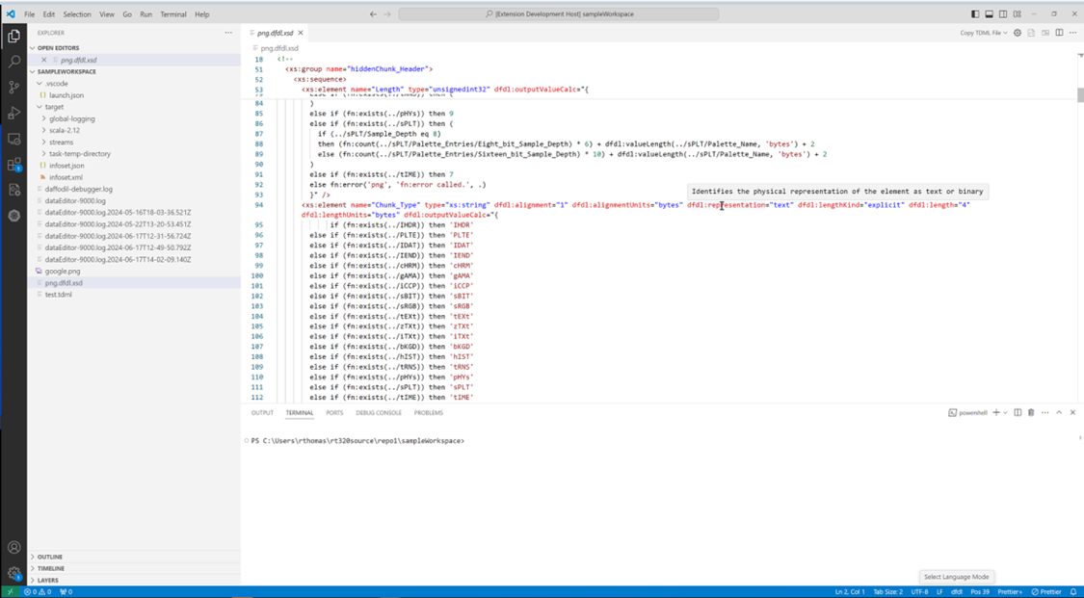

### [Daffodil Data Parse Debugger](https://github.com/apache/daffodil-vscode/wiki/Apache-Daffodil%E2%84%A2-Extension-for-Visual-Studio-Code:-v1.4.0#debugging-a-dfdl-schema-using-the-apache-daffodil-extension-for-visual-studio-codes-bundled-daffodil-data-parse-debugger)

The Apache Daffodil™ Extension for Visual Studio Code provides a Daffodil Data Parse Debugger which enables the developer to carefully control the execution of Apache Daffodil™ parse operations. Given a DFDL Schema and a target data file, the developer can step through the execution of a parse line by line, or until the parse reaches some developer-defined location, known as a break point, in the DFDL Schema. What is particularly helpful is that the developer can watch the parsed output, known as the “infoset”, as it’s being created by the parser, and see where the parser is parsing in the data file. This enables the developer to quickly discover and correct issues, improving DFDL Schema development and testing cycles.

### [Data Editor](https://github.com/apache/daffodil-vscode/wiki/Apache-Daffodil%E2%84%A2-Extension-for-Visual-Studio-Code:-v1.4.0#data-editor-1)

The Apache Daffodil™ Extension for Visual Studio Code provides an integrated data editor. It is akin to a hex editor, but tuned specifically for challenging Daffodil use cases. As an editor designed for Daffodil developers by Daffodil developers, features of the tool will evolve quickly to address the specific needs of the Daffodil community.

### [Daffodil Test Data Markup Language (TDML)](https://github.com/apache/daffodil-vscode/wiki/Apache-Daffodil%E2%84%A2-Extension-for-Visual-Studio-Code:-v1.4.0#tdml-support)

The Apache Daffodil™ Extension for Visual Studio Code provides TDML support. TDML is a way of specifying a DFDL schema, input test data, and expected result or expected error/diagnostic messages, all self-contained in an XML file. A TDML file is often useful just to ask a question about how something in DFDL works. For example, when uploading files to the daffodil users mailing list, it may be easier to upload a zip file containing a TDML file, the DFDL Schema file, the input data file, and, optionally, the infoset file. Sending this file to the users mailing list will allow other users to unpack your zip file and run your test case. It becomes even easier if you have multiple test cases. It allows for a level of precision that is often lacking, but also often required when discussing complex data format issues. As such, providing a TDML file along with a bug report is the absolutely best way to demonstrate a problem. You can read more about TDML [here](https://daffodil.apache.org/tdml/) on the Apache Daffodil™ website.

# Prerequisites

This guide assumes VS Code and a Java Runtime Environment (Java 8 or greater) are installed.

* [Install VS Code, version 1.82.0 or greater](https://code.visualstudio.com/download)
* [Install Java Runtime 8 or greater](https://docs.oracle.com/goldengate/1212/gg-winux/GDRAD/java.htm#BGBFJHAB)
* On Linux, glibc 2.31 or greater is required

# Installing the Apache Daffodil™ Extension for Visual Studio Code

The Apache Daffodil™ Extension for Visual Studio Code can be installed using one of two methods.

## Option 1: Install the Apache Daffodil™ Extension for Visual Studio Code From the Visual Studio Code Extension Marketplace

The Apache Daffodil™ Extension for Visual Studio Code is available in the [Visual Studio Code Extension Marketplace](https://marketplace.visualstudio.com/vscode). This option is recommended for most users.

## Option 2: Install the Latest .Vsix File From the Apache Daffodil™ Extension for Visual Studio Code Release Page

The latest .vsix (the file extension used for VS Code extensions) file can also be downloaded from the Apache Daffodil™ Extension for Visual Studio Code [releases page](https://github.com/apache/daffodil-vscode/releases) and installed by either:

* Using the command-line via code --install-extension <path-to-downloaded-vsix-file>; or
* Using the “Extensions: Install from VSIX” command from within VS Code by opening the Command Palette (Mac = Command+Shift+P, Windows/Linux = Ctrl+Shift+P), and typing vsix to bring up the command and pointing it at the downloaded .vsix file.

# DFDL Schema Authoring Using Code Completion

## Set the Editor to “dfdl” mode

Since DFDL Schema files end with .xsd (XML Schema Definition or XSD), the editor needs to be informed specifically that DFDL mode is desired over the more general XML mode. The mode is selected in the status bar at the bottom of the editor window.

## DFDL Schema Authoring Features

Auto suggest is triggered using control space or typing the beginning characters of an item. Typing one or more unique characters will further limit the results.

📝 **NOTE:** Intellisense is *context aware*, so there is no need to begin a block with <, just start typing the tag name and code completion will automatically handle it as appropriate.

Code completion can be used to add a schema block, with just a couple of keystrokes. Code completion can make short work out of completing a DFDL Format Block, offering context-sensitive suggestions attribute values.

The > or / characters are used to close XML tags. Use tab to select an item from the drop down and to exit double quotes.

Code completion supports creating self-defined dfdl:complextypes and dfdl:simpleTypes.

The tab key can be used to complete an auto-complete item within an XML tag. After auto-complete is triggered, typing the initial character or characters will limit the suggestion results. Inside an XML tag a space or carriage return will trigger a list of context sensitive attribute suggestions.

XPath expressions can be code completed.

# Debugging a DFDL Schema Using the Apache Daffodil™ Extension for Visual Studio Code’s Bundled Daffodil Data Parse Debugger

## Debug Configuration

Debugging a DFDL Schema needs both the DFDL Schema to use and a data file to parse. Instead of having to select the DFDL Schema and the data file each time from a file picker, a “launch configuration” can be created, which is a JSON description of the debugging session.

To create the launch profile:

1. Select Run -> Open Configurations from the VS Code menubar. This will load a launch.json file into the editor. There may be existing configurations, or it may be empty.
2. Press Add Configuration... and select the Daffodil Debug - Launch option.

Once the launch.json file has been created it will look something like this

{  
 "type": "dfdl",  
 "request": "launch",  
 "name": "Ask for file name",  
 "program": "${command:AskForProgramName}",  
 "stopOnEntry": true,  
 "data": "${command:AskForDataName}",  
 "infosetOutput": {  
 "type": "file",  
 "path": "${workspaceFolder}/infoset.xml"  
 },  
 "debugServer": 4711  
}

This default configuration will prompt the user to select the DFDL Schema and data files. If desired, the “program” and “data” elements can be mapped specifically to the user’s files to avoid being prompted each time.

📝 Note: Use ${workspaceFolder} for files in the VS Code workspace, and use absolute paths for files outside of the workspace.

{  
 "type": "dfdl",  
 "request": "launch",  
 "name": "DFDL parse: My Data",  
 "program": "${workspaceFolder}/schema.dfdl.xsd",  
 "stopOnEntry": true,  
 "data": "/path/to/my/data",  
 "infosetOutput": {  
 "type": "file",  
 "path": "${workspaceFolder}/infoset.xml"  
 },  
 "debugServer": 4711  
}

## Launch a DFDL Parse Debugging Session

Using the launch profile above a DFDL parse: My Data menu item at the top of the Run and Debug pane (Command-Shift-D) will display. Then press the play button to start the debugging session.

In the Terminal, log output from the DFDL debugger backend service will display. If something is not working as expected, check the output in this Terminal window for hints.

The DFDL Schema file will also be loaded in VS Code and there should be a visible marking at the beginning where the debugger has paused upon entry to the debugging session. Control the debugger using the available VS Code debugger controls such as setting breakpoints, removing breakpoints, continue, step over, step into, and step out.

## Other Options for Launching a DFDL Parse Debugging Session

* **Option 1:**
  + Open the DFDL Schema file to debug
  + From inside the file open the Command Palette (Mac = Command+Shift+P, Windows/Linux = Ctrl+Shift+P)
  + Once the command Palette is opened start typing Daffodil Debug:
    - Option 1 = Daffodil Debug: Debug File - This will allow for the user to fully step through the DFDL Schema. Once fully completed, it will produce an infoset to a file named SCHEMA-infoset.xml which it then opens as well.
    - Option 2 = Daffodil Debug: Run File - This will run the DFDL Schema, producing the infoset to a file named SCHEMA-infoset.xml.
* **Option 2:**
  + Open the schema file to debug
  + Click the play button in the top right, two options will be provided:
    - Option 1 = Debug File - This will allow for the user to fully step through the schema (WIP). Once fully completed, it will produce a infoset to a file named SCHEMA-infoset.xml which it then opens as well.
    - Option 2 = Run File - This will run the DFDL Schema, producing the infoset to a file named SCHEMA-infoset.xml which it then opens as well.

## Custom DFDL Debugger Views

### Infoset Tools

Find the infoset tools from the command menu (Mac = Command+Shift+P, Windows/Linux = Ctrl+Shift+P)

### Inputstream Hex Viewer

Find the hex view from the command menu (Mac = Command+Shift+P, Windows/Linux = Ctrl+Shift+P)

# TDML Support

When uploading files to the mailing list, it may be easier to upload a zip file containing a TDML file, the DFDL Schema file, the input data file, and, optionally, the infoset file. Sending this file to the mailing list will allow other users to unpack your zip file and run your test case. It becomes even easier if you have multiple test cases.

To Generate a TDML file, use similar steps for Launching a DFDL Parse Debugging Session: * Open the DFDL Schema file * From inside the file, open the Command Palette (Mac = Command+Shift+P, Windows/Linux = Ctrl+Shift+P) * Once the Command Palette is opened, select the Daffodil Debug: Generate TDML command * From there, you will be asked to provide the input data file, the TDML test case name, the TDML test case description, and the location/name for the TDML file.

Visual steps to generate a TDML file

Configure launch.json to generate a TDML file. 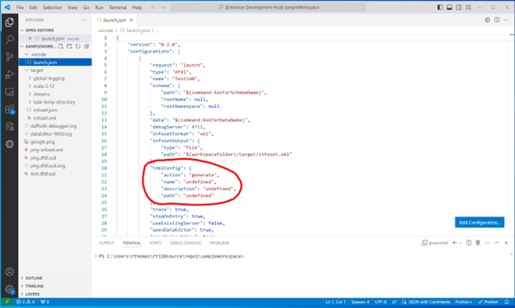

Run the debug extension, choose a dfdl schema and data file. Make sure the language mode is DFDL. 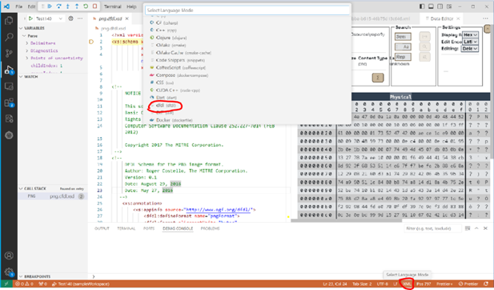

Press the continue button to produce the infoset. 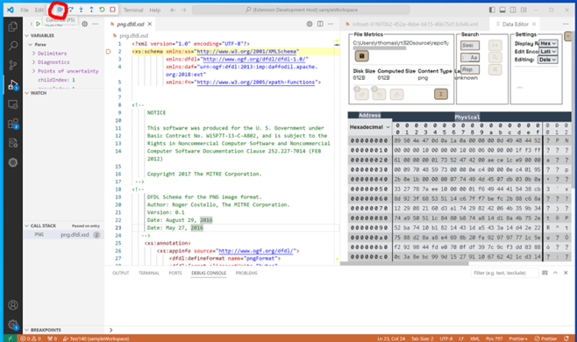

When the infoset generates, a temporary TDML schema will generate. 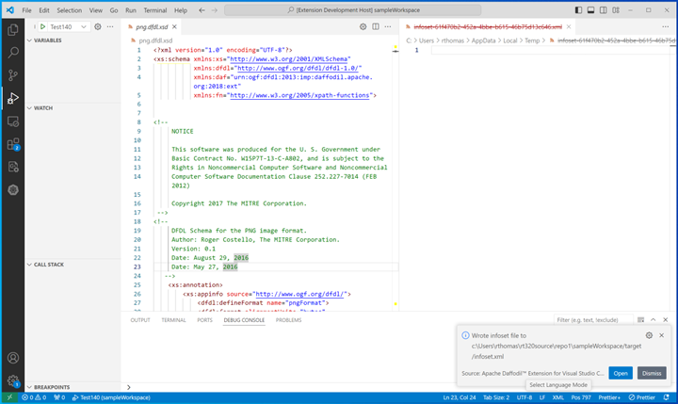

Once the Daffodil Parse has finished, an infoset and a TDML file will be created. The TDML file contains relative paths to the DFDL Schema file, input data file, and infoset file. When creating an archive for these files, preserve the directory structure in the archive.

Visual steps to copy the temporary TDML file to your project.

Close all windows except the dfdl schema window. Click “Copy TDML File” in the dropdown.  
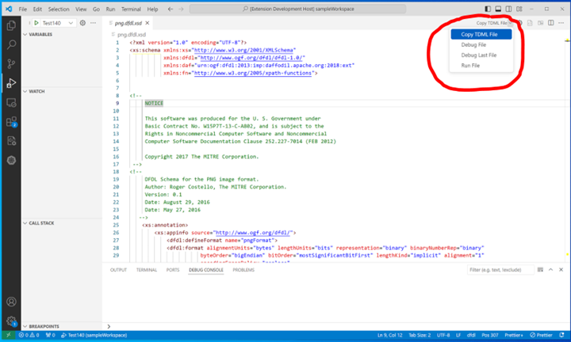

Enter a name for the TDML file, click “Save TDML File.  
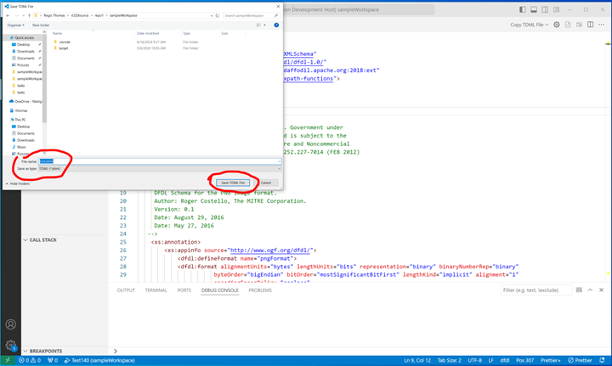

Close the dfdl schema in the editor window. Click the explore tab to verify file is in project folder.  
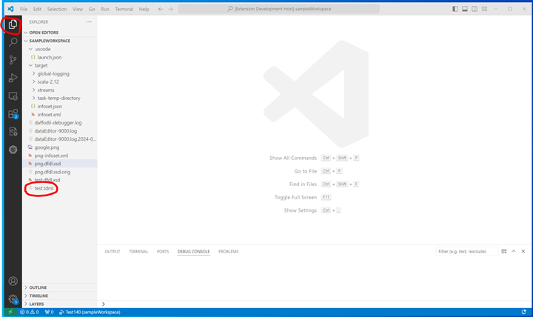

To Append a new test case to an existing TDML file, use similar steps for Generating a TDML file: * Open a TDML file * From inside the file, open the Command Palette (Mac = Command+Shift+P, Windows/Linux = Ctrl+Shift+P) * Once the Command Palette is opened, select the Daffodil Debug: Append TDML command * Or select the Append TDML option at the top right of window * From there, you will be asked to provide the input data file, the TDML test case name, the TDML test case description, and the TDML file * The Append option will append the TDML from the temp directory to the currently open TDML if the two files are different

Visual steps to append to a TDML file

To append to the existing TDML file, open the TDML file and click the button in the upper right corner to open in a text editor.  
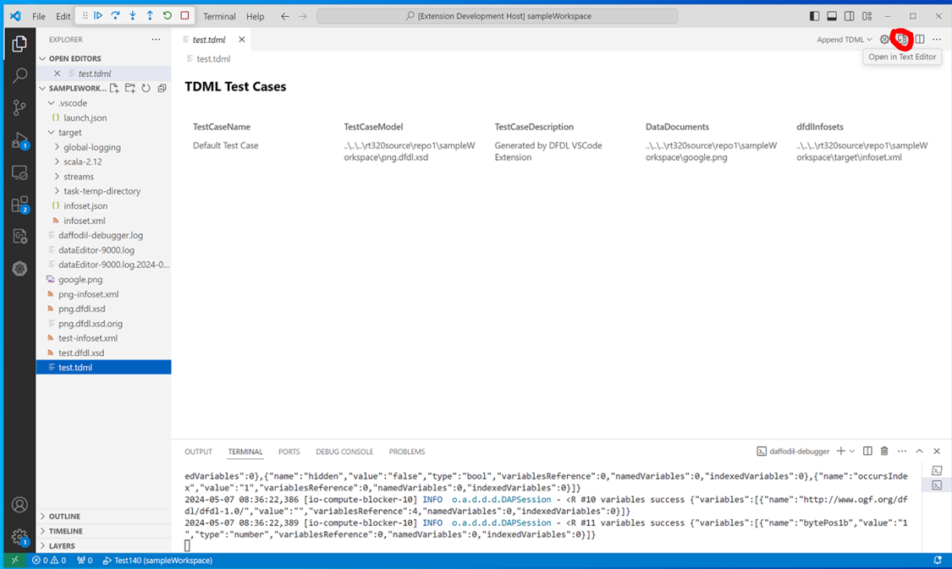

Change the test case name and save the file. 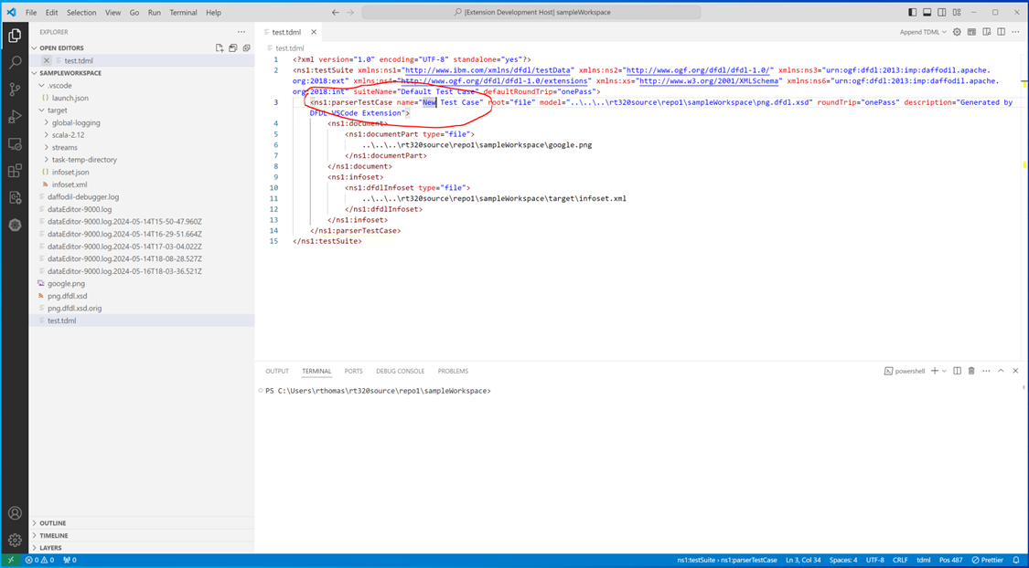

Select append from the TDML dropdown menu at the upper right. 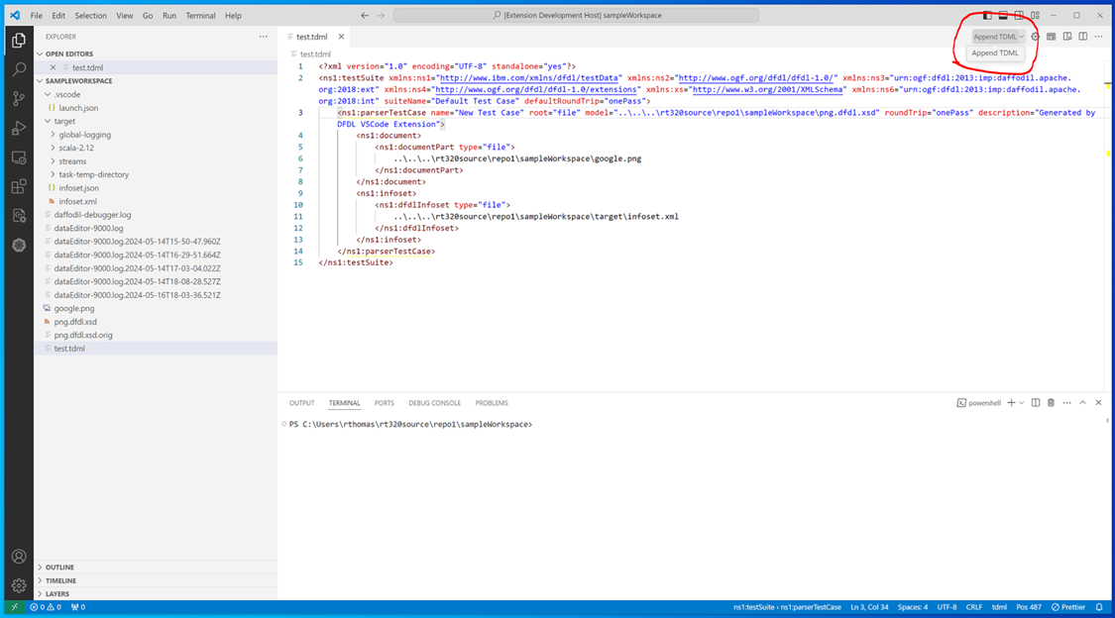

The original default test case from the temp directory will be appended to the saved TDML file with the renamed new test case. 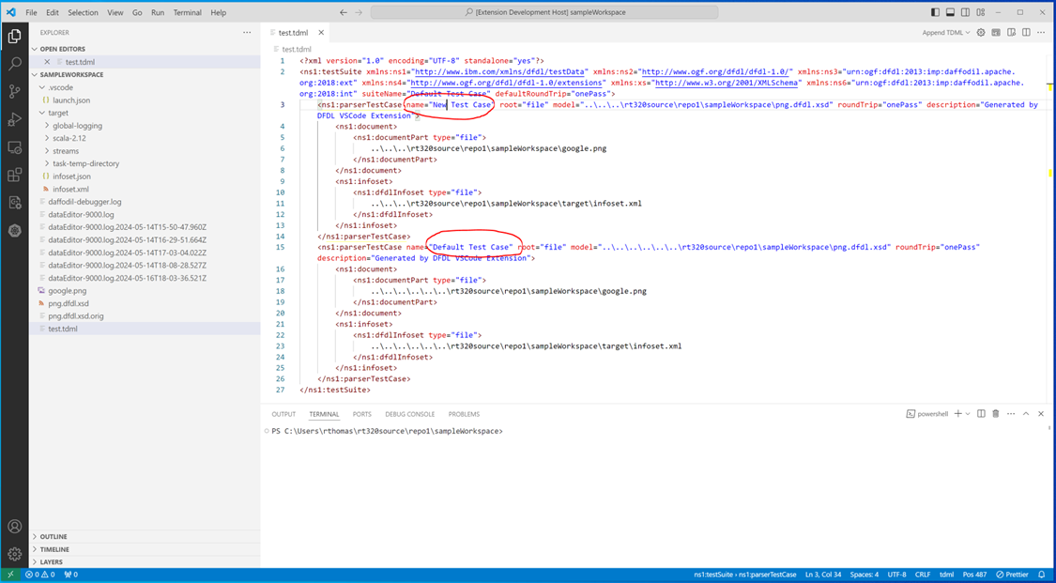

Once the Daffodil Parse has finished, an infoset will be created, and a test case will be added to the existing TDML file. The TDML test case name OR description can be shared between test cases, but no two test cases should share TDML test case names and descriptions. To create an archive for a TDML file with multiple test cases, the same guidelines for creating an archive from a TDML file created from a ‘Generate TDML’ operation should be followed. All DFDL schema files, input data files, the TDML file, and, optionally, the infosets should be added to the archive. Additionally, any directory structure should be preserved in the archive to allow for the relative paths in the TDML file to be resolved.

When running a zip archive created from another user, extract the archive into your workspace folder. If there is an infoset in the zip archive that you wish to compare with your infoset, make sure that the infoset from the zip archive is not located at the same place as the default infoset for the Daffodil Parse that will be run when executing a test case from the TDML file. This is because the Daffodil Parse run by executing the TDML test case uses the default location for its infoset and will overwrite anything that already exists there.

To Execute a test case from a TDML file, use the following steps: * Open a TDML file * From inside the file, open the Command Palette (Mac = Command+Shift+P, Windows/Linux = Ctrl+Shift+P) ’ * Once the Command Palette is opened, select the Daffodil Debug: Execute TDML command or select Execute TDML for the dropdown menu * From there, you will be asked to select TDML test case name, and TDML test case description

Visual steps to execute a TDML file

Click on the explore tab to display the file view. Select a TDML file. 

After the TDML file opens select “Execute TDML” option from dropdown. 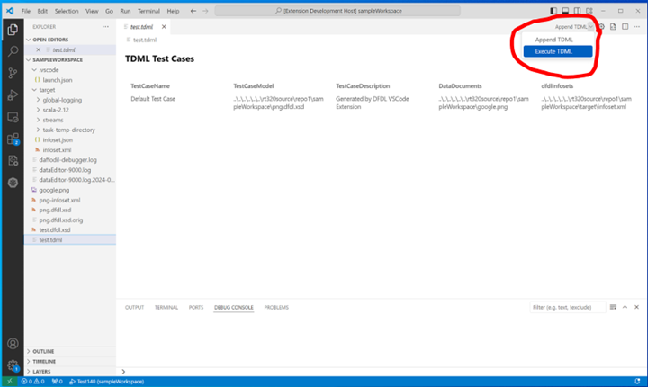

Quickly select a test case and description. 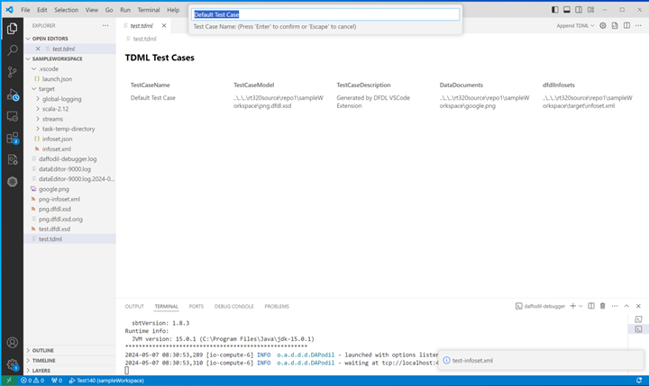

The dfdl schema and a new infoset will utilizing using the values from the TDML file. 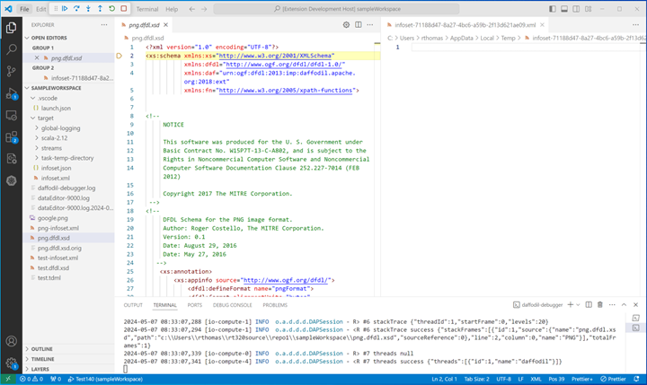

A Daffodil Parse will then be launched. The DFDL Schema file and input data file to be used is determined by the selected test case in the TDML file. The infoset that is generated from this parse can optionally be compared to an infoset included in the zip archive the TDML file was extracted from.

# Data Editor

This version of the Apache Daffodil™ Extension for Visual Studio Code includes a new Data Editor. To use the Data Editor, open the VS Code command palette and select Daffodil Debug: Data Editor.

A notification message will appear that informs where the Data Editor will write its logs to. If problems happen, check this log file for clues.

Once the extension is connected to the server, the bottom left corner of the Data Editor shows the version of the Ωedit™ server powering the editor, and the port its connected to. Hovering over the filled circle shows the CPU load average, the memory usage of the server in bytes, the server session count, the server uptime measured in seconds, and the round trip latency measured in milli-seconds.

After selecting a file to edit, there will be a table with controls at the top of the Data Editor.

The first section of the table is called File Metrics and it contains the path of the file being edited, its initial size in bytes, the size as the file is being edited, and the detected Content Type. When changes are committed, the Save button will become enabled, allowing the changes to be saved to file. The Redo and Undo buttons will redo and undo edit change transactions that have been applied. The Revert All button will revert all edit changes that have been applied since the file was opened. The Profile button will open the Data Profiler and allow profiling of all or a portion of the edited file.

The Data Profiler allows for byte frequency profiling of all or a section of the file starting at an editable start offset and ending at an editable end offset, or an editable length of bytes. The offsets and lengths will use the chosen Address Radix. The frequency scale can be either Linear or Logrithmic. The graph can have either an ASCII overlay that appears behind the graph, or None for no overlay behind the graph. Hover over the bars to see the byte frequency and value. The frequency data can be downloaded as a Comma Separated Value (CSV) file using the Profile as CSV button. Click anywhere outside the Data Profiler to close it.

📝 Note: The maximum length of bytes that can be profiled in this version is capped at 10,000,000 (10M).

The second section of the table is called Search, and it allows for seeking to a desired offset and searching of byte sequences in the given Edit Encoding in the edited file. The Seek input box uses the selected Address Radix as the seek radix. If the Edit Encoding can be case-insensitive, a Case Insensitive toggle (located inside the Search input box) will be displayed allowing for that option to be enabled. The found sequences can be examined using the First, Prev, Next, and Last buttons found in this section. The search can be canceled using the Cancel button.

Found sequences can also be replaced in the given Edit Encoding by filling in a replacement sequence and clicking the Replace... button.

The third section of the table is called Settings, and it allows for setting the Display Radix, Edit Encoding, and Editing mode.

The Display Radix can be one of *Hexadecimal*, *Decimal*, *Octal*, or *Binary*, and will affect the bytes displayed in the Physical viewport.

The Edit Encoding can be one of *Hexadecimal*, *Binary*, *ASCII (7-Bit)*, *Latin-1 (8-bit)*, *UTF-8*, or *UTF-16LE* and will affect the selected bytes being edited in the Edit viewport.

In Single Byte Edit Mode, individual bytes may be *deleted*, *inserted* (to the left or to the right of the selected byte), and *overwritten* in the Single Byte Edit Window that appears when a byte in the Physical or Logical viewports is clicked.

Mouseover the buttons of the Ephemeral Edit Window to determine what each button does. Mouseover the Input Box and it will show the byte offset position in the Address Radix selected radix. Buttons will become enabled or disabled depending on whether there is valid input in the Input Box or not. Values entered in the Input Box must match the format set by the byte Display Radix when editing bytes in the Physical viewport or be in *Latin-1 (8-bit ASCII)* format when editing bytes in the Logical viewport.

When clicking on a single byte in either the Physical or Logical viewports, the Data Inspector will populate giving the value of the byte in latin-1, and various integer formats with respect to the selected endianess. The Data Inspector will also show the byte offset position in the Address Radix selected radix. All of the values in the Data Inspector are editable by clicking on the value and entering a new value.

In Multiple Byte Edit Mode, a segment of bytes is selected from either the Physical or Logical viewports, then the selected segment of bytes is edited in the Edit viewport using the selected Edit Encoding.

Now changes are made in the selected Edit Encoding.

When valid changes have been made to the segment of bytes in the Edit viewport, the Apply button will become enabled.

Once editing of the selected segment is completed and is valid, the Apply button is pressed, and the edited segment replaces the selected segment. As with changes made in Single Byte Mode, changes in Multiple Byte Edit Mode are also applied as edit transactions that can be undone and redone.

Byte addresses can be expressed in *hexadecimal*, *decimal*, or *octal*. The selected Address Radix is also what is used entering an offset into the Offset input and for offsets and length in the Data Profiler. If an offset was entered in the Offset input and the Address Radix is changed, the offset will automatically be converted into the selected radix.

The Data Editor supports light and dark modes. The mode is determined by the VSCode theme. If the VSCode theme is set to a light theme, the Data Editor will be in light mode. If the VSCode theme is set to a dark theme, the Data Editor will be in dark mode.

## Navigation

The Data Editor can be navigated using the mouse or keyboard.

Clicking on the File Progress Indicator Bar will navigate to the position in the file that corresponds to the position clicked.

Below the File Progress Indicator Bar are a series of buttons that allow for navigating the file. The Home button will take you to the beginning of the file, the Page Up button will take you to the previous page of the file, the Page Down button will take you to the next page of the file, and the End button will take you to the end of the file. The Line Up button will take you to the previous line of the file, and the Line Down button will take you to the next line of the file.

## Keyboard Shortcuts

The following keyboard shortcuts are available in the Data Editor:

For any input box, including the input box for Single Byte Editing Mode, ENTER will submit the input, and ESC will cancel the input.

When using Single Byte Editing Mode, CTRL-ENTER will insert a byte to the left of the selected byte, SHIFT-ENTER will insert a byte to the right of the selected byte ,and DELETE will delete the selected byte.

When browsing the data in the Physical or Logical viewports, Home will take you to the top of the edited file, End will take you to the end of the edited file, Page-Up will give you the previous page of the edited file, Page-Down will give you the next page of the edited file, Arrow-Up will give you the previous line of the edited file, and Arrow-Down will give you the next line of the edited file.

# Known Issues in v1.4.0

Debugger * Ubuntu 24.02 (release date 04/25/2024) When using the debugger to step through a dfdl schema utilizing the step over action, the step over action will trigger dfdl intellisense to display a list of suggestions when a line in the schema is reached that results in output to the infoset. This problem can be mitigated by disabling “WaylandEnable” by uncommenting “#WaylandEnable=false” in the /etc/gdm3/custom.conf configuration file and rebooting the system. * Ubuntu 20.04 (release date 04/23/2020) When using the debugger to step through a dfdl schema utilizing the step over action, the step over action will trigger dfdl intellisense to display a list of suggestions when a line in the schema is reached that results in output to the infoset. A cause and solution have not yet been discovered. Note that the mitigation listed above for Ubuntu 24.04 was not found to be an effective mitigation for Ubuntu 20.04. * Ubuntu 22.04 (release date 04/21/2022) The debugger problem that occurs with the step over action in Ubuntu 20.04 and Ubuntu 24.04 has not been found to be a problem in Ubuntu 22.04. * At this time the debugger step into and step out actions have no code behind them, using either button results in an unrecoverable error. We have not found a way to disable the step into and step out buttons. This problem occurs in all Operating Systems.

# Reporting Problems and Requesting New Features

If problems are encountered or new features are desired, create tickets [here](https://github.com/apache/daffodil-vscode/issues).

# Getting Help

If additional help or guidance on using Daffodil and its tooling is needed, please engage with the community on [mailing lists](https://daffodil.apache.org/community/) and/or review the [archives](https://lists.apache.org/list.html?users@daffodil.apache.org).

# Contributing

If you would like to contribute to the project, please checkout our [Development.md](https://github.com/apache/daffodil-vscode/blob/main/DEVELOPMENT.md) for instructions on how to get started.

# Additional Resources

* [Apache Daffodil™ Extension for Visual Studio Code Wiki](https://github.com/apache/daffodil-vscode/wiki)
* [Apache Daffodil Repository](https://github.com/apache/daffodil)

# Apache Daffodil™ Extension for Visual Studio Code: Brief

The Apache Daffodil™ Extension for Visual Studio Code is an extension to the Microsoft® Visual Studio Code (VS Code) editor, designed for Data Format Description Language1 (DFDL) Schema developers. The purpose of the Apache Daffodil™ Extension for Visual Studio Code is to ease the burden on DFDL Schema developers by enabling rapid development of high-quality DFDL Schemas, with syntax highlighting, code completion, data file editing, and debugging of DFDL Schema parsing operations using Apache Daffodil™.

## DFDL Schema Development

The Apache Daffodil™ Extension for Visual Studio Code provides syntax highlighting to improve the readability and context of the text and provide instant feedback to the developer indicating the structure and code are syntactically correct.

The Apache Daffodil™ Extension for Visual Studio Code provides code completion offering context-aware code segment predictions that can dramatically speed up DFDL Schema development by reducing keyboard input, memorization by the developer, and typos.

## Daffodil Data Parse Debugger

The Apache Daffodil™ Extension for Visual Studio provides a Daffodil parse debugger enabling the developer to control the execution of Daffodil parse operations. Given a DFDL Schema and a target data file, the developer can step through the execution of parse operations line by line, or until the parse reaches some developer-defined location, known as a breakpoint, in the DFDL Schema or the data being parsed. What is particularly helpful is that the developer can watch the parsed output, known as the “Infoset”, as it is being created by the parser, and watch where the parser is parsing in the data file. This enables the developer to quickly discover and correct DFDL Schema issues, making development and testing cycles more efficient.

## Data Editor

The Apache Daffodil™ Extension for Visual Studio Code provides an integrated data editor that is tuned specifically for challenging Daffodil use cases. It is designed to support large files, of any type, that are well beyond the limits of the standard text editor in VS Code. The Data Editor allows for editing of single or multiple bytes in different encodings. The Data Editor can seek to file offsets, search and replace byte sequences, profile data, and determine a file’s content type. Features of the Data Editor will evolve to address the specific needs of the Daffodil community.

### Data Debugger Integration

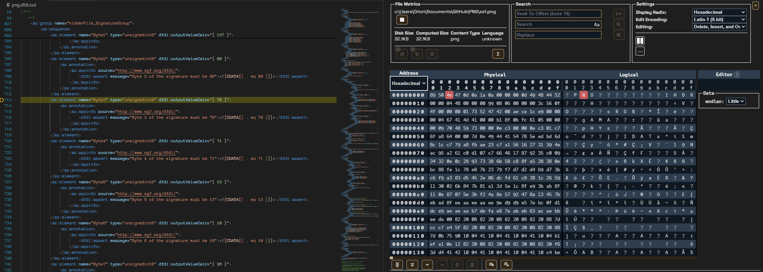

image

The Data Editor component can be configured to run alongside and open the designated file specified by the data debugger. During this operation, whenever the debug session steps to a new byte position or stops from a breakpoint, the data content within the Data Editor will illustrate the byte location.

# Getting Help

If additional help or guidance on using Apache Daffodil™, Apache Daffodil™ Extension for Visual Studio Code, or DFDL development in general is needed, please engage with the Daffodil user and developer communities on [mailing lists](https://daffodil.apache.org/community/) (https://daffodil.apache.org/community/) and/or review the [list archives](https://lists.apache.org/list.html?users@daffodil.apache.org) (https://lists.apache.org/list.html?users@daffodil.apache.org).

# Community Feedback

Apache Daffodil™ and the Apache Daffodil™ Extension for Visual Studio Code are Apache Software Foundation (ASF) projects, are free open-source software, and under active development. Feedback and contributions are welcome.

# Additional Resources

* [Apache Daffodil™ Home Page](https://daffodil.apache.org) (https://daffodil.apache.org)
* [Apache Daffodil™ Extension for Visual Studio Code Repository](https://github.com/apache/daffodil-vscode) (https://github.com/apache/daffodil-vscode)
* [Apache Daffodil™ Extension for Visual Studio Code Wiki](https://github.com/apache/daffodil-vscode/wiki) (https://github.com/apache/daffodil-vscode/wiki)
* [Apache Daffodil™ Library Repository](https://github.com/apache/daffodil) (https://github.com/apache/daffodil)

# Legal

Apache, Apache Feather Logo, Apache Daffodil, Daffodil, and the Apache Daffodil logo are trademarks of The Apache Software Foundation. Visual Studio Code, and VS Code are trademarks of Microsoft® Corporation. All rights reserved.

#### Footnotes

1 Data Format Description Language (DFDL) is a standard from the Open Grid Forum (www.ogf.org), available [here](https://ogf.org/documents/GFD.240.pdf) (https://ogf.org/documents/GFD.240.pdf).

Copyright © 2023 [The Apache Software Foundation](https://www.apache.org/). Licensed under the [Apache License, Version 2.0](https://www.apache.org/licenses/LICENSE-2.0). Apache, Apache Daffodil, Daffodil, and the Apache Daffodil logo are trademarks of The Apache Software Foundation.

[Brief](https://github.com/apache/daffodil-vscode/wiki/Home)

User Documentation * [1.4.0 - latest](https://github.com/apache/daffodil-vscode/wiki/Apache-Daffodil%E2%84%A2-Extension-for-Visual-Studio-Code:-v1.4.0) * [1.3.1](https://github.com/apache/daffodil-vscode/wiki/Apache-Daffodil%E2%84%A2-Extension-for-Visual-Studio-Code:-v1.3.1) * [1.3.0](https://github.com/apache/daffodil-vscode/wiki/Apache-Daffodil%E2%84%A2-Extension-for-Visual-Studio-Code:-v1.3.0) * [1.2.0](https://github.com/apache/daffodil-vscode/wiki/Apache-Daffodil%E2%84%A2-Extension-for-Visual-Studio-Code:-v1.2.0)

[Roadmap](https://github.com/apache/daffodil-vscode/wiki/Apache-Daffodil%E2%84%A2-Extension-for-Visual-Studio-Code:-Roadmap)

[Development](https://github.com/apache/daffodil-vscode/wiki/Apache-Daffodil%E2%84%A2-Extension-for-Visual-Studio-Code:-Development)